Author Visit by Katherine Magnoli on May 27th,2015
At Palmetto Elementary
The Adventures of KatGirl by Katherine Magnoli
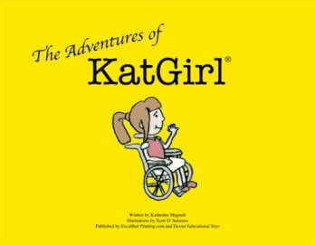
A heart-warming series about a superhero in a wheelchair that helps children who are being bullied. Visit her website: http://realspecialeducation.com/

Please check the book(s) you would like to order.
___ The Adventures of KatGirl
___ The Adventures of KatGirl and the Birthday Party
___ The Adventures of KatGirl and the Spelling Bee
___ The Adventures of KatGirl School Project
___ Las Aventuras de SuperKat

- 1 Book = $ 7.00
- 2 Books = $10.00
- 3 Books= $15.00
- 4 Books = $20.00
- 5 Books = $25.00

***Please make checks payable to Katherine Magnoli

