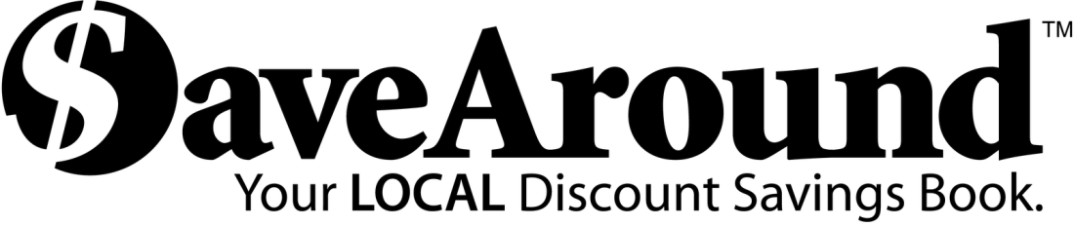

Dear Parents and Friends:
Palmetto Elementary is sponsoring the SaveAround sale to raise funds for our school. SaveAround is a coupon book that offers hundreds of buy-one-get-one-free discounts, along with many other great discounts!!
You buy one book for just $20!! You will find out that the book pays for itself after using it just 2 or 3 times. You make your money back and more!!!

Start Date: 10/26/2015
Coupon book and envelope/order form will be sent home with each student. For every 5 books a student sells, he/she will get 1 book FREE!
End Date: 11/06/2015
Please return order form and payment for all orders or unsold book to your child’s teacher. If only one book was sold, please keep your book and return only money and order form. Orders will be filled within 10 days of return.

Please make checks payable to:

Palmetto Elementary PTA

- Please have your student return this envelope/order form to their teacher by (NOVEMBER 6th) with their NAME on it, and MONEY for additional sales inside.

- Remember, this is NOT meant as a door-to-door sale to strangers. The safety of your student is our first concern. Parents, try to sell to relatives, neighbors and co-workers.

FOR EVERY 5 BOOKS YOU SELL, YOU GET 1 FREE!!!

If you didn't sell a book – return the sample book loaned to you by the company.
IT MUST BE RETURNED OR THE SCHOOL WILL BE CHARGED!!

Thank you for supporting your community!!

