Ark of Taste photo contest

Are you a shutterbug who loves delicious and distinct foods? Want to get your image in front of the tens of thousands of people in the Slow Food USA network? Then help us celebrate your local food treasures for a chance to have your photo appear as the cover image on the Autumn 2016 issue of Slow: An Eater’s Digest.
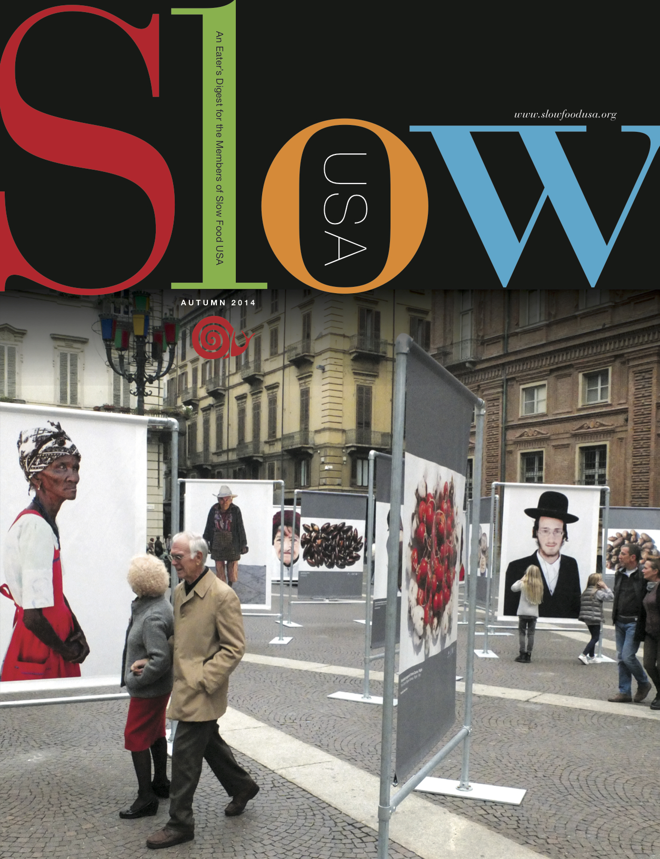
How to win
The featured photo will be selected by Slow Food USA’s editorial team from a set of images and media depicting an Ark of Taste Food that is submitted as a collection to the Google Cultural Institute’s gallery of Ark of Taste foods.
submitting an entry
First, read the description of Slow Food’s collaboration with the GCI and what materials to collect in order to create a complete collection for the gallery. (on the back of this page)
Then, start collecting images! If you would like to work with your regional Ark of Taste committee to find great photo ops, email arkoftaste@slowfoodusa.org with your state of residence to be connected with those fine folks.
When you’ve collected at least four images showing the food, people, landscape and gastronomy of an Ark of Taste product, send them to arkoftaste@slowfoodusa.org

Deadline for submission is August 1st
Ark of taste online gallery - FAQ
Slow Food is working with Google’s Cultural Institute platform to better tell the story of the products on the Ark of Taste! In order to create each online exhibit, we are seeking out photographs and other media that document these Ark products: the products themselves, the territory they come from, the people behind them, and their gastronomic traditions! To create each exhibit, we need a minimum of 7-8 images for each product. We need your help in collecting these materials to document products near you!
Send your contributions to arkoftaste@slowfoodusa.org
documentation
The Cultural Institute exhibits are a unique chance to show the world agrobiodiversity from the Slow Food point of view! We want to show the world the culture, the landscapes and the people behind these endangered foods. Each exhibit should document…

The food itself: in the field; for sale at markets; through various stages (i.e. planting, flowering and harvest for plants; different life stages of animals; dough being mixed, leavened, and baked for bread, etc. ); images of unique characteristics or details of the product; the production process for transformed products (i.e. from flowering to collection to filtering and packaging for honey; the harvest of the grain, the mashing and distilling, the packaging and the usage of a distillate or spirit, etc.).

The landscape: the territory where products grow, raise or are harvested; fields or ecosystems where the product is found; the events and spaces where it is produced or eaten

The people: indigenous communities who safeguard this product; farmers, ranchers, foragers and fishermen; the people who process or transform the product (i.e. from grain into flour); people using special tools in planting, harvesting or processing the product.

The gastronomy: further cooking or processing of the product (i.e. pickling, preserving, drying); dishes where the Ark of Taste product is the main component; rituals, events or holidays where the product is celebrated and served
technical requirements

- images must be in .JPG format
- images should be at least 1 MB in file size. Exceptions may be made for extraordinary images
- cannot contain any added text, added copyrights or visible watermarks. All images will be credited with the copyright holder’s name – and a URL of the website of the photographer if desired – on the last slide of the show
- video or audio clips should be in one of the following formats: .MOV, .MPEG4, MP4, .AVI, .WMV, .MPEGPS, .FLV. 3GPP, WebM, or links to videos previously uploaded to YouTube.com. Vidoes will be uploaded to YouTube, on a profile maintained by Slow Food, in order to be embedded in the Cultural Institute exhibit.
- video or audio clips should be under 5 minutes in length. Longer clips may be broken up into shorter parts.
- any multimedia sent must be the property of the sender and/or sent with express, written permission from the copyright holder for Slow Food’s use (we can also use media in the public domain, with proper credit)

