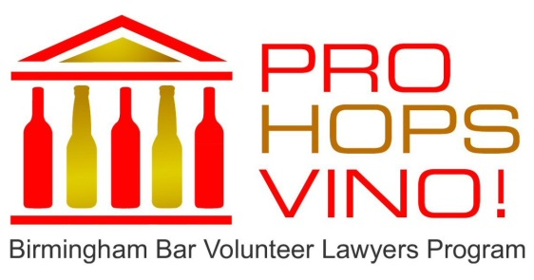
Pro Hops Vino! October 8th, 6 pm to 9 pm
420 20th Street North, Suite 1400

I would like to attend Pro Hops Vino!

[ ] Single Ticket - $40

[ ] Event Host - $150 (Two tickets and name recognition)

[ ] I am interested in a personal or company sponsorship. Please contact me with additional details.

Name: _______________________________

Email: _______________________________

Phone: _______________________________

[ ] I have attached a check/cash for the ticket price (Please make checks payable to the Birmingham Bar Volunteer Lawyers Program. Mail or bring your payment to the Birmingham Bar Center, 2021 Second Ave N., Birmingham, AL 35203.)

[ ] Please send me an invoice for my ticket request

[ ] I plan to register through prohopsvino.com

Please visit prohopsvino.com for more event information including sponsorship packages.

