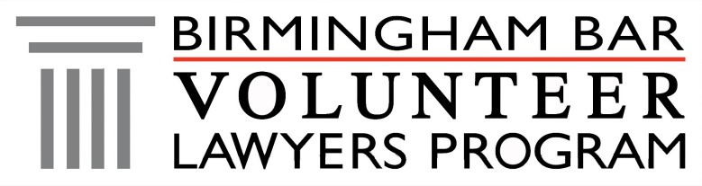
HELP Clinic
Homeless Experience Legal Protection

What: Free Legal Aid from Birmingham Volunteer Lawyers
When: 1st and 3rd Tuesday, 8:30-10 a.m.
Who: Women and Children Experiencing Homelessness

YOU CAN GET HELP WITH

- ID and Driver’s License
- Evictions
- Collections

- Guardianships
- Wills
- Divorce

- Child Support
- Visitation/Custody
- Other legal issues

FINANCIAL GUIDELINES
Our program is for low-income individuals. You will be accepted into the program if you cannot
afford an attorney. You will be asked questions about your income at check-in.

FEDERAL GOVERNMENT CITIZENSHIP REQUIREMENT
At check-in, you will sign an attestation affirming that you are a United States Citizen or are in the country legally. This requirement is waived if you are a domestic violence victim.

COMMON QUESTIONS
Q: Will I be assigned a volunteer attorney to handle my case?
A: Most likely no. The lawyers you meet with are volunteering only for the time of the clinic. However, in some cases, we will try and find a volunteer attorney to represent you.
Q: Can I come to a HELP Clinic more than once?
A: Yes. You may visit as many times as you need in order to resolve your legal issue.
Q: Am I entitled to a court-appointed attorney?
A: No. That is only for criminal cases and for termination of parental rights cases in Family Court, if the judge determines you are indigent.
Q: Can you waive my court fees?
A: No. We are not part of the court system and cannot waive court fees.
Q: Who is responsible for following up on my case?
A: Your case is your responsibility. You are responsible for attending court and follow-up.
For more information visit vlpbirmingham.org

