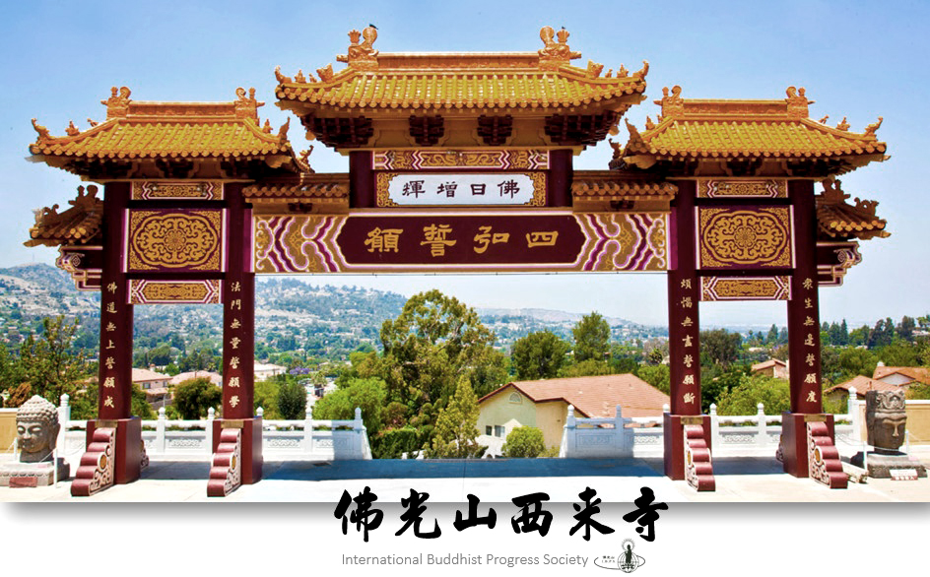
On Saturday, September 19th, the Lamplighters are hosting a tour and vegetarian luncheon at the Hsi Lai Buddhist Temple at 3456 Glenmark Drive, Hacienda Heights, 91745.
(626)961-9697. www.hsilai.org

Total cost for the tour and lunch is $10 per person. We will meet in the parking lot, at the Temple, at 11:00am. If you would like to meet at church, and car pool, please meet at the church parking lot by 10:15am.

Please RSVP to Cindy Speakman, at (626)292-1624, or dolphinlover827@yahoo.com, no later than September 9th, so reservations can be made. All are welcome to join this event, which should be interesting and educational, as well as enjoyable!

About the temple:

Hsi Lai Temple encompasses 15 acres and a floor area of 102,432 square feet. The temple's Ming (1268-1644 C. E.) and Ching (1644-1911 C.E.) dynasty architecture is faithful to the traditional style of buildings, gardens and statuary of traditional ancient Chinese monasteries. Hsi Lai means "coming to the West" and signifies the dedication of the Fo Guang Shan Buddhist Order to spread the teachings of the Buddha to those in the West. Hsi Lai Temple was built to serve as a spiritual and cultural center for those interested in learning more about Buddhism and the Chinese culture. It is the idea of Venerable Master Hsing Yun to propagate "Humanistic Buddhism" and to create a Pure Land here on earth. Hsi Lai Temple is built to fulfill these goals in the United States. The temple's objectives are to nurture Buddhist missionaries through education, to propagate Buddhism through cultural activities, to benefit society through charitable programs, and to edify the populace through Buddhist practices.

