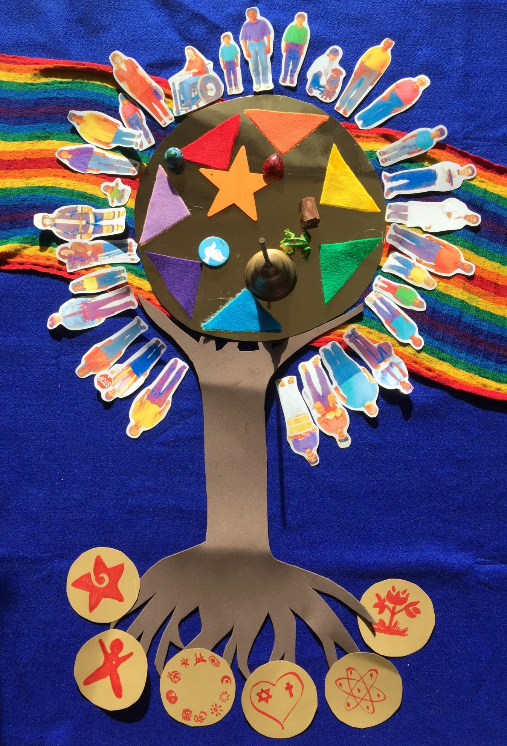
We gather together on the Rainbow Path of our Unitarian Universalism community, the way in which we try to live our lives. We gather around the mystery (gold circle). This is the Spirit of Love and Justice and Truth, the Spirit of Mystery that some people call God.
Now who can be on the path? (look at the variety of people gathered. Note there is always space for more.)
You know, sometimes, it’s hard to be in community. One person might do something that another one doesn’t like. They might think someone is being unfair.
So in our Unitarian Universalist community, on the rainboth path we make promises to each other about how we are going to treat each other, so that we all get along, and do what’s right. So we have 7 principles, you might call them promises.
Our first promise is red for Respect People. Each person is special just by being his or her self. Each person is like a gift. You are special just by being yourself. You are a gift. (Star)
Our second promise is orange for Offer Fair and Kind Treatment to All People. Since we believe that all people are gifts, we need to be kind and fair to them. (Heart)
Our third promise is yellow for Yearn to Accept and Learn About Ourselves, Others, and the Mystery. By thinking about ourselves and other people and learning& celebrating our differences, we are reminded by this flame that we are all connected to the Mystery that some people call God. (flame)
Our fourth promise is green for Grow by Exploring What is True and Right in Life. It’s sometimes hard to decide what is true and right, so this flower reminds us that we grow as people by exploring answers to our questions. We may find different answers to the same questions, or questions that have no answers, but we keep on asking.
(frog – ready to leap into learning)
Our fifth promise is blue for Believe in our ideas and Act on them. Once we figure out what is right and true for us, this bell reminds us that we have to try to do what’s true and right, not just talk about it. The bell is that little voice inside us that lets us know when something we do is right or wrong. (Bell)
Our sixth promise is indigo or dark blue for Insist on Freedom, Justice, and Peace for all People. We try to do what’s right and we want all people to have freedom and justice in their lives. Justice means being fair to everyone. Peace means living together in harmony. (dove)
The seventh and last promise is violet, a kind of purple color, for Value our home, Earth, that we share with all living beings. We value each living being as a gift just like we do people. This Earth reminds us again that we are all connected in our lives. We need to be careful of what we do so that all living beings on Earth will have clean water, and clean air, and enough places to live. We need to remember that we are only one being on the Earth and that there are many others that we need to respect. (globe)
There are seven promises we make to each other to help us be in community. They remind us that we are connected to each other and to the spirit of Love or Mystery which some people call God.
So we have
Red for Respect All Beings
Orange for Offer Fair and Kind Treatment to All
Yellow for Yearn to accept and Learn about ourselves, others,
and Mystery
Green for Grow by Exploring what is true and right in life
Blue for Believe in our ideas and Act on them
Indigo for Insist on Freedom, Justice, and Peace for all beings
Violet for Value our home, Earth that we share with all living things
Unitarian Universalists didn’t just make these promises or principles up one day. They came from many different ideas about how we should live that people have been talking about and studying for a long, long, time.

If this tree is the Unitarian Universalism religion,then the promises would be the leaves and the seeds on the tree. They have grown because we have many roots feeding us.
The roots of our beliefs are called our Sources.
There are six of them that Unitarian Universalists have chosen.
Our beliefs come from our sense of wonder. We learn by asking why.
Our beliefs come from the people of long ago and today whose lives remind us to be kind and fair. We learn by hearing their stories.
Our beliefs about how to live together come from all the world’s religions. We learn from many cultures.
Our beliefs come from Jewish and Christian teachings that tell us to love all others as we love ourselves. We learn from our past history.
Our beliefs come from the use of reason and the discoveries of science. We learn by using our minds.
Our beliefs come from the harmony of nature and the sacred circle of life. We learn by knowing we are a part of nature and the cycles of life.
Our promises come from our sources and what we have learned from them. But they come from somewhere else too—
Our sources come from the Spirit of Love and Mystery, which some people call God.

