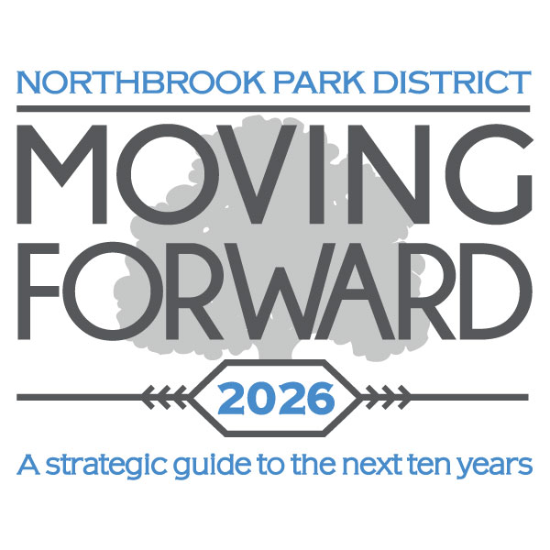

Help Shape the Future of Parks and Recreation in Northbrook!
The Northbrook Park District is working with a planning team from the Hitchcock Design Group to develop a 10-year Comprehensive Master Plan. The planning process, Moving Forward 2026, will combine input from residents with a scientific analysis of our assets and programs.

We encourage residents to share their feedback about our parks, facilities and programs.
You can get involved by:

- Attending a community discussion led by Hitchcock Design Group on December 2 from 7-8:30pm at the Leisure Center
- Joining the conversation through an online discussion portal for residents at nbparks.org

Your participation and input are critical to the success of this project. Thank you in advance for sharing your thoughts!

