Summertime and Sensory Inclusive Programs at Milpitas Library
By Lauren Teixeira, Children’s Librarian at Milpitas Library
At the Milpitas Library this summer - it’s all about inclusion! Join us for Sensory Story Times for young children and their caregivers every 4th Wednesday of the Month at 10:30 am and join us for Sensory Friendly Movie Screening on Sunday, July 17th at 2 pm in the library’s auditorium.
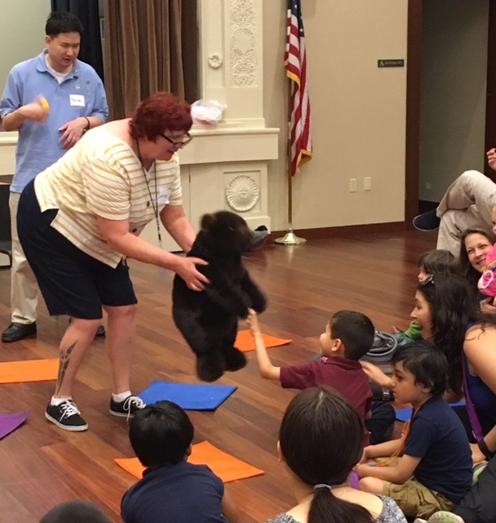
What is Sensory Story Time?
Sensory Story Time is an interactive, educational program that is especially designed for children with sensory integration challenges, but can be enjoyed by all children.
Sensory Story Time combines books, songs, movement, and therapeutic activities to stimulate all five senses and promote learning.
If your child has difficulty sitting through one of the library’s other story times, this inclusive program of stories, songs and activities may be just what you are looking for!
Who can attend?
Sensory Story Time at Milpitas Library.
Children’s Librarian, Lauren Teixeira and Stompy-the-Bear shake hands with a happy kindergartener.
Any child ages 1 to 8 years old can attend with a parent/caregiver, however space is limited and registration is required.
Summer Sensory Story Times will be held on Wednesday, June 22 and July 27th.
To register online: tinyurl.com/hjlcegx
To register by email: lteixeira@sccl.org
To register by phone: 408-262-1171, ext. 3621

What are Sensory Friendly Movie Screenings?
A Movie Showing for Families and Guests Living with Autism or Other Special Needs
The Sensory-Friendly Movie Screening will have captions turned on, lights turned up, sound turned down, and invitees are free to get up move, dance, walk, or shout! This program is free and people of all abilities are invited to attend!
The movie screening will follow the adventures of Belle, a bright young woman who finds herself in the castle of a prince who’s been turned into a mysterious beast.
No registration is needed for the Sensory Friendly Movie Screening on Sunday, July 17 at 2 pm in the Auditorium at the Milpitas Library.
For more information on the Sensory Friendly Movie Screening please call:
408-262-1171, ext 3600

