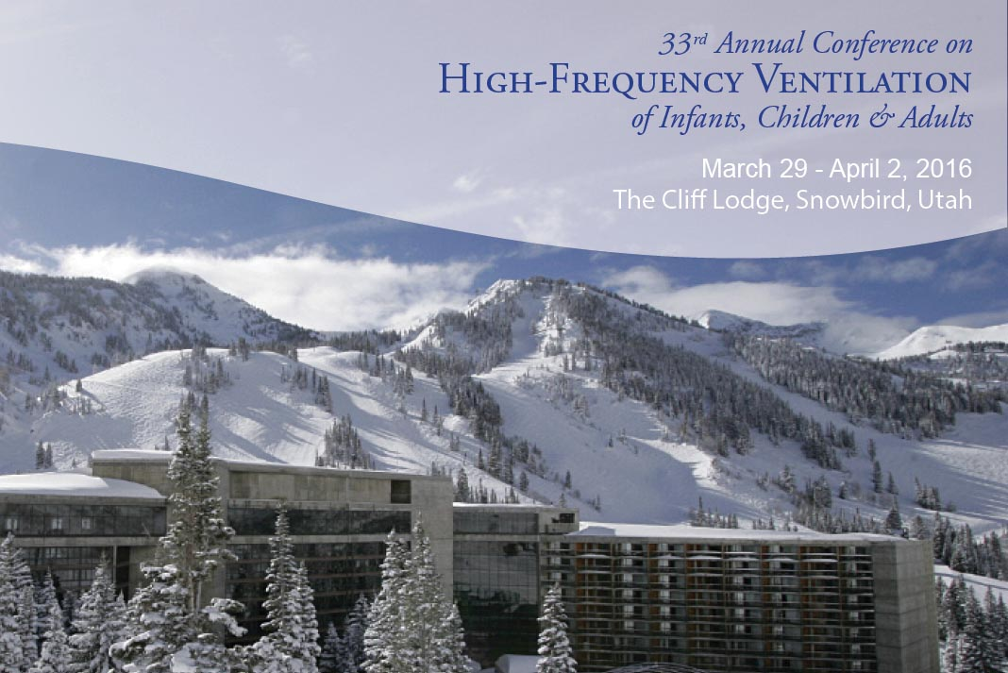
33rd Annual Conference on High Frequency Ventilation and Critical Care of Infants, Children & Adults
March 29, 2016 - April 2, 2016 -- The Cliff Lodge -- Snowbird, UT United States
Conference Description: Lectures by Experts, Abstracts, and Poster Presentations, Along With ‘Hands On’ Workshops on Hi-Frequency Ventilation.
Registration: http://highfrequencyconference2016.eventbrite.com
Conference Agenda: http://paclac.org/event/33rd-annual-conference-on-high-frequency-ventilation/
1. “Oxygen use: the good, bad and ugly” Robin Steinhorn, MD, UC Davis
2. “Humidified Hi-Flow nasal cannula- Not Just for the Newborn anymore” Brad Yoder, MD, University hospital, Salt Lake City, UT
3. “Post-operative cardiac management of Congenital Heart Diseases and outpatient management of patients with Pulmonary Hypertension” Stuart Burger, MD, UC Davis, CA
4. “Newer use of ECMO for other than O2 delivery and CO2 removal” Andriy Batchinsky, MD, Brooks Army Medical Center
5. “Cell Free Hemoglobin: Role in ARDS and Other Organ Dysfunction” Lorraine B. Ware, Vanderbilt University
6. “Various Ventilator Strategies in the management of ARDS” Stephen Durdak, DO, Wilford Hall Medical Center
7. “Inhaled Nitric oxide use in diseases other than Neonatal Pulmonary Hypertension” Don Null, MD, UC Davis, CA
Abstract Submissions: The planning committee invites you to submit Abstracts from original studies for presentation or poster session at the 33rd Annual conference. Abstracts MUST be submitted by November 23, 2015. Abstracts submitted at other meetings can be submitted. Please review the Abstract Submission Guidelines on-line before submission.
Continuing Education For Physicians, Nurses, And Respiratory Therapists Will Be Available.

