TIP SHEET
Where do I find my HART scheduling reports?
Previously you received scheduling related reports from HART via email or by accessing HART directly. With the conversion to Epic many of these reports have changed location and look different. This Tip Sheet will guide you in locating previously used reports by providing the previous report name, new report name, guidance on how and where to access the report and what has changed within the report.
Management and operations assisted in identifying critical go-live reports however additional reports will be updated and replaced after go-live. This document will continue to be updated and users will be advised as new reports are released. A list of SCHED reports expected to be replaced or updated by Epic reports is available after signing in with your Health Account at https://documents.health.usf.edu/display/UHP/HART+SCHED+Reports+and+their+Epic+Replacements.
Should you encounter any difficulties accessing the reports either via Hyperspace or HART please contact Technical Services at (813) 974-6288, via email at support@health.usf.edu or using LiveChat (https://livechat.health.usf.edu/); if using LiveChat please select Epic in the drop-down category box.
PLEASE NOTE: At this time historical data will not be available on any of the new reports due to the differences in the definition of departments and locations between Epic and GE (PCIS). The Integrated Data Management team is working with Faculty Practice Group management to ensure that this data will be available on a forthcoming release of these reports. Historical data (prior to August 1, 2015) will still be available by running the GE System Scheduling Reports in HART (see section below for additional instructions).

Find My Report
PREVIOUS REPORT NAME | NEW REPORT NAME | WHERE TO ACCESS | WHAT’S DIFFERENT
Anticipated Arrivals from Sched STC and NC | Anticipated Arrivals - EPIC | HART | - Tabs include similar physical buildings using Epic Location  - GE Location is part of the Epic Department Details  - Hellen Ellis Hospital has been removed  - Includes appointments with a status of Confirmed and Scheduled  - Sessions – new definition
Arrivals, Bumps (<30 days), Cancellations, and No Shows by Department/Provider | Completed, Bumps, Cancellations, and No Shows by Department/Provider - EPIC | HART | - Sched Department Prompt – asks for an Epic Department  - Providers are listed in sections by the Epic Department in which they schedule appointments  - Arrivals is changed to Completed  - Cancellations, Bumps, and Internal Cancellations – new definition  - Sessions – new definition
Avg Bumps No Shows Cancels by Dept-Provider | Avg Bumps, No Shows, Cancels by Department/Provider - EPIC | HART | - Sched Department Prompt – asks for an Epic Department  - Providers are listed in sections by the Epic Department in which they schedule appointments  - Cancellations, Bumps, and Internal Cancellations – new definition  - Sessions – new definition
Daily Appointment Arrivals | Daily Appointment Arrivals | Auto-emailed | - Location Facility Name is now Epic Location  - GE Location is no longer displayed  - Sched Department is now Epic Department  - Room columns have been removed
Daily Appointment Volumes | Daily Appointment Volumes - EPIC | HART | - Arrivals is changed to Completed  - Cancellations, Bumps, and Internal Cancellations – new definition  - No Shows – new definition  - Graphs and tables on the second tab represent an Epic Department  - The drill opens to Epic Department level, but you can move through the full hierarchy: Service Area > Location > Department > Provider
Daily Appointment Volumes by Dept | Daily Appointment Volumes - EPIC | HART | - This data will now be accessed through the Daily Appointment Volumes report using the optional department prompt.
Operational Daily Dashboard Automated | Operational Daily Dashboard Automated | Auto-emailed | - Location Facility Name is now Epic Location  - GE Location is no longer displayed  - Sched Department is now Epic Department  - Arrivals is changed to Completed  - Cancellations, Bumps, and Internal Cancellations – new definition  - No Shows – new definition
Operational Daily Dashboard Automated - Summary | Operational Daily Dashboard Automated - Summary | Auto-emailed | - Location Facility Name is now Epic Location  - Arrivals is changed to Completed  - Cancellations, Bumps, and Internal Cancellations – new definition  - No Shows – new definition  - Added a Grand Total
Physician Supply-Demand - Department | Schedule Utilization | Hyperspace | - Using Epic standard report with scheduling data only
Physician Supply-Demand - Physician | Schedule Utilization | Hyperspace | - Using Epic standard report with scheduling data only
Today’s Anticipated Arrivals | Anticipated Arrivals | Auto-emailed | - Tabs include similar physical buildings using Epic Location  - GE Location is part of the Epic Department Details  - Hellen Ellis Hospital has been removed  - Includes appointments with a status of Confirmed and Scheduled  - Sessions – new definition
Weekly Appointment Volumes | Weekly Appointment Volumes - EPIC | HART | - Arrivals is changed to Completed  - Cancellations, Bumps, and Internal Cancellations – new definition  - No Shows – new definition

Finding the GE System Scheduling Reports in HART
With the transition to Epic as our electronic health record many of the existing HART reports that were based on scheduling information from GE will continue to exist; however, they will not report data for any period past July 31, 2015. These reports have been moved to a centralized folder within HART to help prevent any uncertainty.
If you need to access reports to pull historical data they are available in a new folder named GE IDX Historical Reports (Prior to 08/01/2015) in the folder where you previously found that report.
Accessing Epic Reports through Hyperspace

Find a Report
You can find reports by searching the Library.
- Select Epic button > Reports > My Reports. Then select the Library tab.
- Enter the topic of the report you're looking for in the search field.
  - For example, if you want a report to find the case volume for each service over the past month, enter diabetic visit.
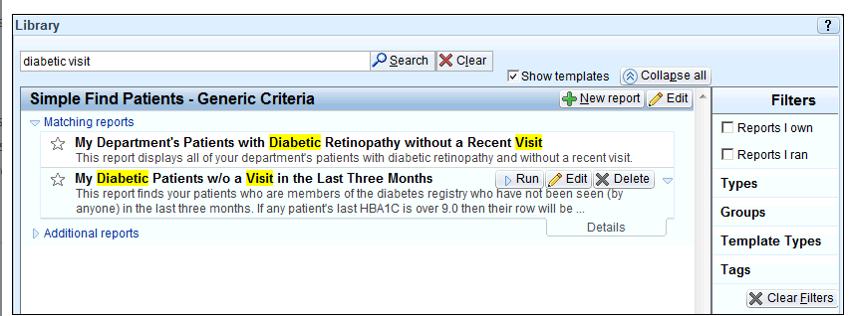
  - To show only reports in your search results, clear the Show templates check box.
- Click Search.
- To limit your search results, you can apply filters, such as searching for Crystal reports related to billing.
  - To search only for reports that you own or reports that you ran, select the appropriate check box.
  - Click Types to view all of the report types, such as applications or departments. Select the check box next to the type(s) by which you want to filter.
  - Click Groups to view all of the reports grouped by more granular workflows or users. Select the check box next to the group(s) by which you want to filter.
  - Click Template Types to view all of the template types. Types can include Reporting Workbench or Crystal reports. Select the check box next to the type(s) by which you want to filter.
  - Click Tags and search for a tag by which you want to filter. Select the check box next to the tag by which you want to filter.
  - Click Clear Filters to remove the filters.

- Select a report.
  - Click Run to run the report with the current settings.
  - Click the to add the report to your Favorites list in My Reports and in your My Reports component for easy access later.
  - Click Edit to change the report's settings. You can then run the report with your edited settings or save it as a new report.

Run (Request) an Epic-Crystal Integration Report
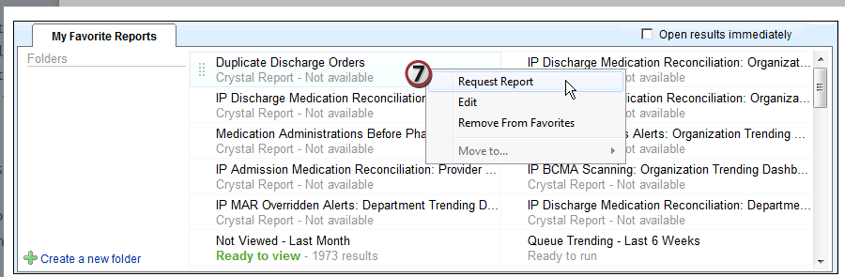
Epic-Crystal reports are run by batch job on a set schedule. Instead of running a report at any time, you must request the report. Crystal reports are indicated by the label below it, which also designates its availability.
- Go to the Epic button > Reports > My Reports > Library tab.
- Enter the topic of the report you're looking for in the search field.
- Click Search.
- Click the to add the report to your Favorites list in My Reports.
- Click the My Reports tab.
- In the My Favorite Reports section, right click on the report you want to run.
- Select Request Report.

Add a report to your list of favorites
Instead of searching for a report each time you want to run it, you can add it to your Favorites list so it is easy to find. If your dashboard includes a My Reports section, favorite reports also appear on your dashboard.
- Go to the Epic button > Reports > My Reports. Select the Library tab and find a report you frequently use.

- Click to the left of the report's name. The star turns yellow to signify that this report is one of your Favorites.
  - To remove the report from your Favorites, click the again. A window appears prompting you to confirm your choice.
  - You can also add a report to your Favorites from the Recent Results section in My Reports by clicking after you run the report.
- The report now appears in your Favorites list on the My Reports tab. You can run or edit it from there.

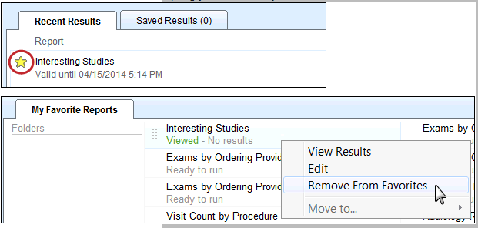
Accessing HART Reports through Epic
While you can still access your reports directly through HART as you have always done, there is now a link to HART in Epic Hyperspace for your convenience.
- Select Epic button > Dashboards > My Dashboards.
- A listing of available dashboards will appear based on your Epic access
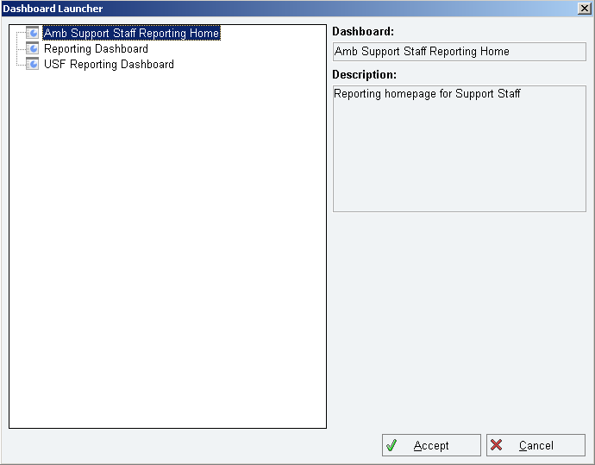
  - Select USF Reporting Dashboard and click Accept.

- A new tab will open with links to HART and HART Access Help.
  - Click on HART.

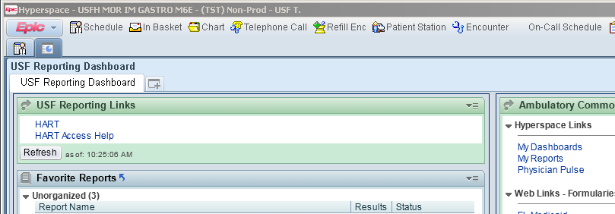

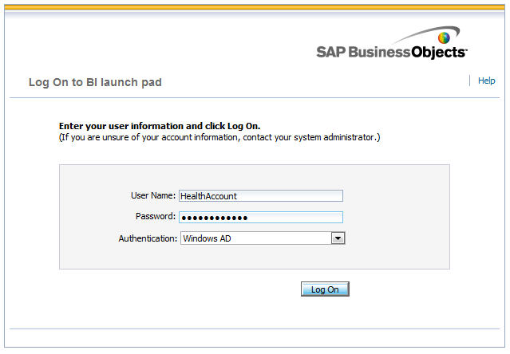
- A new tab will open with the HART Logon screen.
  - Enter your USF Health Account credentials in the first two boxes and ensure that Windows AD is selected for Authentication.
  - Click Log On.

- When logging into HART from Epic for the first time, you will need to set your preferences to open new reports in a tab instead of a new window.
  - In the upper right corner click Preferences.
  - A dialogue box will open to the General preferences settings.
  - Scroll down to Set document viewing location: and click the radio button for In the BI launch pad portal as tabs.
  - Click Save & Close.
NOTE: If you choose not to complete step 5 you will be required to logon to HART twice.

- Navigate to your required report and run the report as you are accustomed.

Special considerations when accessing Epic Hyperspace using Citrix
When running reports while logged into Hyperspace via Citrix, you will be able to access all reports. However, you will be unable to download, export or save reports.

If it’s necessary to download, export or save reports, you will need to be logged in through the VMWare Clinical Desktop.

