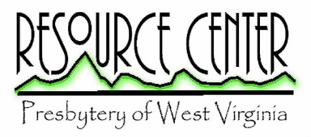
New Resources - March 23, 2016

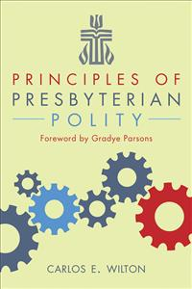
Principles of Presbyterian Polity, Carlos E. Wilton, Geneva Press
Here is a useful guide to Presbyterian Church (USA) governance based on foundational principles. Wilton explains the historical and confessional principles guiding the Book of Order. The author guides us to understand the Form of Government of 2011 which Stated Clerk of the General Assembly, Gradye Parsons eloquently describes in the Foreward saying that in it we “keep our Reformed mindfulness to equip individuals to be thinkers and doers of mission and honor the collective wisdom of councils.”

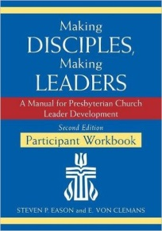
Making Disciples, making Leaders: a manual for Presbyterian Church Leader Development, (leader Guide and participant Workbook), Steven P. Eason & E. Von Clemans, Geneva Press
Two books that go together for leadership training focusing on formation more than information. This is for team building of Deacons and Elders. It is about more than knowing the Rules. It is about leadership.

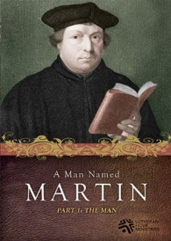
A Man Named Martin, (a video), Lutheran Hour Ministries,
This 80-minute video takes a look at the life of Martin Luther, one of the main architects of the Reformation. A fast-paced combination of talking heads and art from the 17th and 18 centuries, we see Martin Luther’s progression from a youth destined to be a lawyer to a devout and dedicated monk to his defense of his theology and to his death. Viewers may watch the 80-minute television version straight through or as a 5-week study.

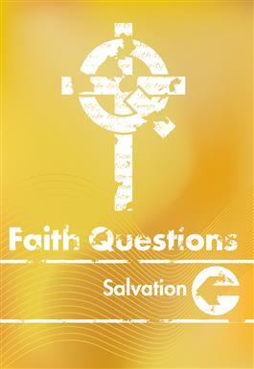
Faith Questions: Salvation, Mark Hinds, published by CMP, a ministry of Presbyterian Mission Agency
Here is the latest of the Faith Questions studies for older youth. The author looks at Salvation starting with the story of the Exodus as God delivers the Israelites from bondage in Egypt. It continues through the work of Jesus and on to the resurrection of Christ. This study is for four sessions. The leader may use this book or may download the Coffeehouse Version which, using a question and discussion model, takes very little preparation.

