April 7, 2016
CTA President Dorval R. Carter, Jr.
CTA Headquarters
567 W. Lake Street
Chicago, IL 60661

Dear President Carter:

Lincoln Central Association was pleased to learn that the CTA will be bringing back the #11 Lincoln Avenue CTA bus route on a pilot basis. We applaud this decision and are hopeful a successful pilot will lead to a permanent restoration of this vital route. We encourage you, however, to expand this pilot in two ways:

1) As currently contemplated, the pilot’s southward route stops at Fullerton just before entering the Lincoln Central neighborhood. We believe the prior route of the bus should be fully restored providing a single, direct route from Howard on the North to downtown by combining it with the current #37 Sedgwick Bus route. This would provide:

- A single ride direct two-way connection to many communities (e.g. River North, Old Town, Lincoln Park, Lakeview, North Center, Lincoln Square).
- Customers to Lincoln Avenue restaurants and retailers, many of whom, especially those serving the Lincoln Central neighborhood, are struggling today.
- A single ride direct connection to vital community institutions (e.g. Chicago History Museum, Sulzer Regional Library, Old Town School of Folk Music, Victory Gardens, Lakeview YMCA), schools (e.g. DePaul University, Lincoln Elementary, LaSalle Language Academy) public parks (e.g. Jonquil, Oz Park, Welles).
- Better transportation access to new residential/retail developments (former Children's Memorial Hospital, Lincoln Centre, Webster Square).
- Easier access for seniors to their doctors, pharmacies and other providers.

2) The length of the pilot be expanded from six months to a full year to allow adequate time for residents of the neighborhoods served to become adequately familiar with the restored service and its route. The route should be well advertised by providing online and printed brochures, social media announcements and by utilizing all neighborhood associations, chambers of commerce and selected businesses, and institutions to assist in generating awareness for the pilot.

We believe expanding the pilot to incorporate our recommendations will provide many benefits to, and strengthen connections between, residents, businesses and institutions in many communities and will ensure a successful pilot of the restored #11 bus route. Thank you in advance for your careful consideration of our suggestions.

Sincerely,
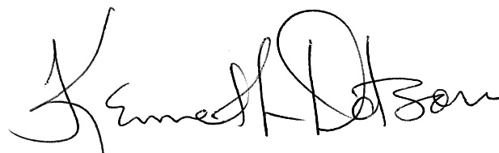
Kenneth Dotson
President

