

**9th Annual Summer Institute**

**June 22-23, 2016**

***Important Work: Teaching Children of Poverty***

***8:00 am – 4:00 pm***

**Chapman Auditorium – McNair Science Building**

**Francis Marion University**

**4800 Patriot Drive – Florence, SC 29506**

**FRANCIS MARION UNIVERSITY**

**CENTER OF EXCELLENCE**

***to Prepare Teachers of Children of Poverty***

The **Center of Excellence to Prepare Teachers of Children of Poverty Summer Institute** is a two-day event designed to provide participants with practical, research-based information focusing on the needs and abilities of children of poverty. The theme of the Summer Institute is “Important Work: Teaching Children of Poverty.” The event will feature four keynote addresses and over 40 breakout sessions focusing on classroom strategies and best practices for under-resourced students.

**Wednesday, June 22 Thursday, June 23**

**KEYNOTE SPEAKER:**

***Gerry Brooks***

***“Spreading Humor Through The World of Education”***

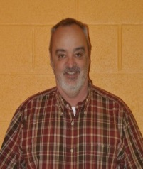

Kentucky Principal, Gerry Brooks, from Liberty Elementary, will be joining us at the Summer Institute. He is a new internet sensation for educators across the nation. What began as a fun video has exploded into a regular commentary that he describes as “spreading humor through the world of education.” If you have not already been introduced to Mr. Brooks, like him on Facebook or follow his channel on YouTube “Lex Prin” to see his daily dose of humor.

**Thursday, June 23**

**KEYNOTE SPEAKER:**

***Carol Ann Tomlinson***

***“Invitations to Learn:***

***Creating Classrooms that Support Learning”***

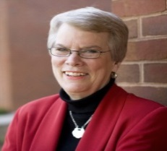

Carol Ann Tomlinson’s career as an educator includes 21 years as a teacher, 12 years as a program administrator of special services for struggling and advanced learners. Special interests throughout her career include differentiation and encouraging creative and critical thinking in the classroom. More information about Tomlinson can be found on her website: http://www.caroltomlinson.com/index.html.

**Wednesday, June 22**

**KEYNOTE SPEAKER:**

***Jo Ann Burroughs***

***“Johnathon”***

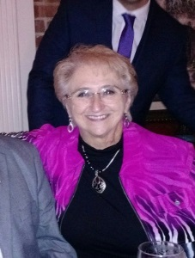

Jo Ann Burroughs was an elementary school principal and a classroom teacher for 31 years before her retirement. As the author of the books, Johnathon and Techr, and a presenter, Jo Ann has carried her message, "Children Need Love, Too," throughout the United States. She believes many children enter classrooms so loaded down with problems from home that they have great difficulty settling into class routines. It is often the teacher of these children who can and does make a difference in their success or failure.

For more information, please call (843) 661-1828 or email [coe@fmarion.edu](mailto:coe@fmarion.edu)

**To register for the Summer Institute, visit our website:** [**http://fmucenterofexcellence.org**](http://fmucenterofexcellence.org)

Complete Registration Form & mail with payment to

**Center of Excellence to Prepare Teachers of Children of Poverty, 4822 E. Palmetto Street, Florence, SC 29506**

**Professional Development Recertification hours will be awarded to ALL participants. South Carolina DSS credit awarded for Early Childhood Education sessions.**

**Wednesday, June 22**

**KEYNOTE SPEAKER:**

***Baruti Kafele***

***“Every Child Deserves a***

***Rock Star Teacher”***



Principal Baruti Kafele is ON FIRE as he has distinguished himself as an award-winning educator, an internationally renowned speaker as well as a best-selling author. Baruti is one of the most sought after speakers for providing effective teaching and leadership strategies to transform student attitudes. More on Principal Kafele can be found on his website: http://www.principalkafele.com/.