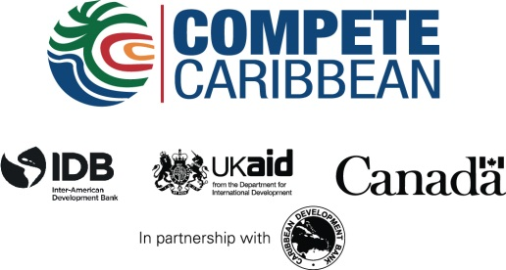

Bahamas Launches MapGuide and Website
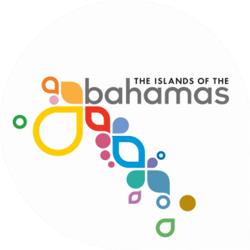

Small and medium-sized businesses (SMEs) in The Bahamas now have access to over 50 million potential customers, thanks to an innovative web site that maximises the country's geo-tourism potential.
Through its Ministry of Tourism (MOT), the Bahamas Government in collaboration with the Inter-American Development Bank (IDB), Compete Caribbean and the National Geographic Society (NGS) created a co-branded MapGuide and interactive website (Visit Here) of The Bahamas Family of Islands, offering information that identifies natural, cultural and historic attractions that define the islands and its people.

The aim of the web site is to boost the Family of Islands' tourism potential by acting as a driver of overall SME development. The website is the first of its kind in the region.

This initiative, launched on November 13, is an integral part of The Bahamas Family of Islands Geotourism Program and is made possible through a solid partnership between MOT, NGS, Compete Caribbean and the Multilateral Investment Fund (MIF) of the IDB.

NGS worked closely with its partners as well as local organizations, businesses and residents to map the best of The Bahamas Family of Islands using their stories and nominations. The MapGuide and website celebrate and sustain what is most distinctive about The Bahamas Family of Islands and promote travel to the region. The Family Islands represents the less populated, yet equally intriguing, island gems of The Bahamas island chain.

These two unique online tools are expected to encourage sustainable economic development and promote long-term stewardship of the islands' distinctive communities, businesses, working landscapes and natural areas. Additionally, leveraging the latent potential of the tourism value chain in the Family Islands to act as a driver for overall small and medium enterprise (SME) development and sectoral linkages is a fundamental objective as well.

The IDB's Representative in The Bahamas, Florencia Attademo-Hirt, congratulated The Bahamas MapGuide website on becoming the first of its kind in the Caribbean. The Bahamas joins 12 other international geotourism destinations which are currently managing co-branded websites and promoting wise destination stewardship.

Covering a melting-pot of unique natural sites, cultures, history and geographies, The Bahamas Family of Islands under the Geotourism Program are: The Abacos, Acklins, Andros, The Berry Islands, Bimini, Cat Island, Crooked Island, Eleuthera/Harbour Island and Spanish Wells, The Exumas, Grand Bahama (East and West Ends), Inagua, Long Island, Mayaguana, Ragged Island, Rum Cay and San Salvador.

