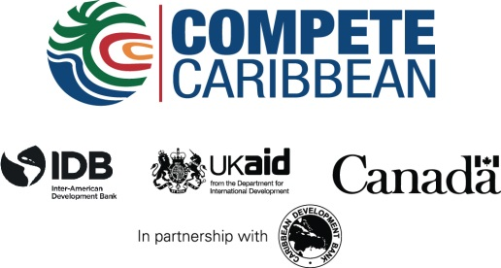

A Market Based Solution for Clean, Affordable Water in Haiti
Project Location: Haiti
Project Start Date: July 4th, 2014
Project End Date: May 4th, 2016
Grant Funds Approved: $500,000
Envelope: Direct Firm Support
Total Project Cost: 1,451,774

The Project
DloHaiti Inc. is a for-profit venture providing safe drinking water to consumers in underserved countries such as Haiti. The firm seeks to improve its model by decentralizing production, putting it closer to consumers. By doing so, DloHaiti can lower the cost of water, improve water quality, and deliver services that improve convenience and access. Its target markets are under-served communities in peri-turban and rural areas where customers currently pay high prices for drinking water. DloHaiti aims to produce and distribute affordable, clean drinking water that is above the World Health Organization’s (WHO) standards for drinking water quality. Traded under the brand name ‘Ovive’, water will be sold per gallon from kiosks in 3-5 gallon jugs or as a fill-your-own-bottle system. The company will also retail locally produced chlorine doses for water purification. Water obtained from underground, surface or piped water sources will be purified by ultra-filtration and reverse osmosis. This will be done onsite at the solar-powered kiosks. Each kiosk will have dispensing capacity of between 2,500-5,000 gallons per day and storage systems for 2,000-4,000 gallons of water.

Objective: To pilot a commercial decentralized network of water treatment facilities and local distribution networks, to improve the supply of clean, affordable drinking water to high demand, but under-served communities in Haiti through the development of a decentralized network of water treatment facilities and local distribution networks.

How donor funds are being used:
- Procurement of technical consultancies associated with the operation of the kiosks’ solar panels and water filtration systems;
- Marketing and launching activities of the kiosks;
- The development of software to be integrated into hand held devices to facilitate remote operations;
- Support for the distribution delivery program
Achievements Thus far:
- Five (5) kiosks retrofitted, powered by solar energy and generating tremendous sales ;
- Installation of Water Treatment and Piping completed for five sites/kiosks;
- Technical consultants for the operations of the current kiosks;
- Distribution and delivery network established for the kiosks currently in operation;
- Phases 1-3 of the Remote Monitoring and Customer Relationship Database custom software developed;
- Hydrogeological Engineering Study and water testing completed for 2-10 sites

