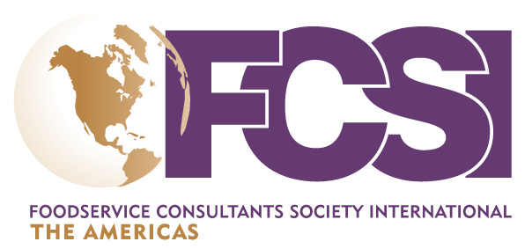

CALL FOR PRESENTATIONS

Foodservice Consultants Society International The Americas Conference

Nashville, Tennessee

April 14-16, 2016

The deadline for responding to the Call for Presentations is Friday, April 10, 2015

The 2016 Conference Planning Committee is looking for your best, most creative session ideas for FCSI’s 2016 Conference. We encourage you to submit your proposal regardless of session type, or room set. We’re looking for cutting edge topics, the latest trends in Kitchen Design, Business Practices, Collaboration, Contracts, POS, Digital Signage, Furniture, Technology Methods, etc. Sessions can be open discussion-based, or any untraditional format you can think of…no idea is too crazy! We embrace craziness!

This Call for Presentations is the first step in soliciting your input to create a diverse conference full of quality education and fun. If you are interested in participating in the conference by organizing and moderating an educational session, complete the PRESENTATION PROPOSAL portion of the form below.

The Committee seeks proposals that fit roughly into one of the following themes. Please note, these can be applicable to any area of foodservice, for example, “Trends” exist in all facets of the industry.

TOPICS

Trends (food, technology, equipment, design, sustainability, menus, etc.)

Food Supply and Sources

Safety and Sanitation

“Green” Practices & Design / Energy Efficiency / Energy Management

Code Compliance and Regulatory Issues

Emergency Preparedness

Productivity & Efficiency (design, operations)

Also we will be debuting two NEW FAST PACED sessions in Nashville

“Energize” will be a breakout session about YOU. Each presenter will be allowed 10 minutes with automated slide progression. ANY topic is welcome (no sales pitches please). Talk about your personal and/or professional accomplishments.

“Open Space” will be a breakout session with no agendas. This breakout will utilize a unique seating arrangement with all topics decided by attendees and answers provided by your colleagues. Have a burning question or problem to solve? This is YOUR session.
CALL FOR PRESENTATIONS PROPOSAL INSTRUCTIONS

Deadline for submission of the “Call for Presentations” proposal is Friday, April 10, 2015.

The “Call for Presentations” proposal must be submitted to Wade Koehler by email (wade@fcsi.org) or fax (309.585.2292).

The “Call for Presentations” proposal must be fully completed. An incomplete proposal may be eliminated from additional consideration.

NOTE: Presentations cannot be sales pitches.

PROPOSAL SUBMITION DETAILS

Name Click here to enter text.

Company Click here to enter text.

Phone Click here to enter text.

E-mail Click here to enter text.

The Conference Program Committee will meet in April to review and evaluate all workshop proposals received by March 20, 2015. If your proposal is accepted, you will be notified and asked to submit a final, comprehensive proposal.

PRESENTATION PROPOSAL:

I am interested in organizing and moderating a session for the conference. My proposed title is:

Click here to enter text.

Brief description of my proposed workshop (700 characters maximum):

Click here to enter text.

What type of instructional method will you use for this session? Please select ONE from the list below:

☐ Case Study

Provide a case study on a topic where an organization has exemplified the topic you are presenting on.

☐ Interactive

The content leader acts more as a moderator as the attendees interact with one another on a topic. Could be a game, debate, table discussions, etc.

☐ Listen n' Learn

More traditional presentation style where the content leader share information on a specific topic.

☐ Panel with Q & A

Three or four content leaders presenting on a topic allowing for questions from attendees.

☐ Energize

minute session with automated slide advances.

LEARNING OBJECTIVES & KEY TAKEAWAYS: What are the key takeaways attendees will be walking away with following your session?

Click here to enter text.

Click here to enter text.

Click here to enter text.

5. The material level of my proposed session is (select ONLY ONE of the following)

☐ Introductory

☐ Intermediate

☐ Advanced

The material of my proposed session would appeal to:

☐ Design Consultants

☐ MAS Consultants

☐ Equipment Manufacturers

☐ Operators

☐ All of the Above

7. List of potential presenters, starting with yourself. The Planning Committee plans to offer a diverse program which includes a mixture of presentation formats: (1) single presenters who are recognized as experts in their field; (2) co-presenters, who will represent pro and con positions when a topic calls for opposing viewpoints; and (3) panels with a moderator, for broad or complex topics. I understand that I should not confirm the participation of any presenter unless I am notified that my proposal has been selected by the program committee.
Click here to enter text.

Registration and Travel Info
All session leaders and participants receive a complimentary registration and one night hotel accommodation. Session leaders are responsible for their own related travel costs.

