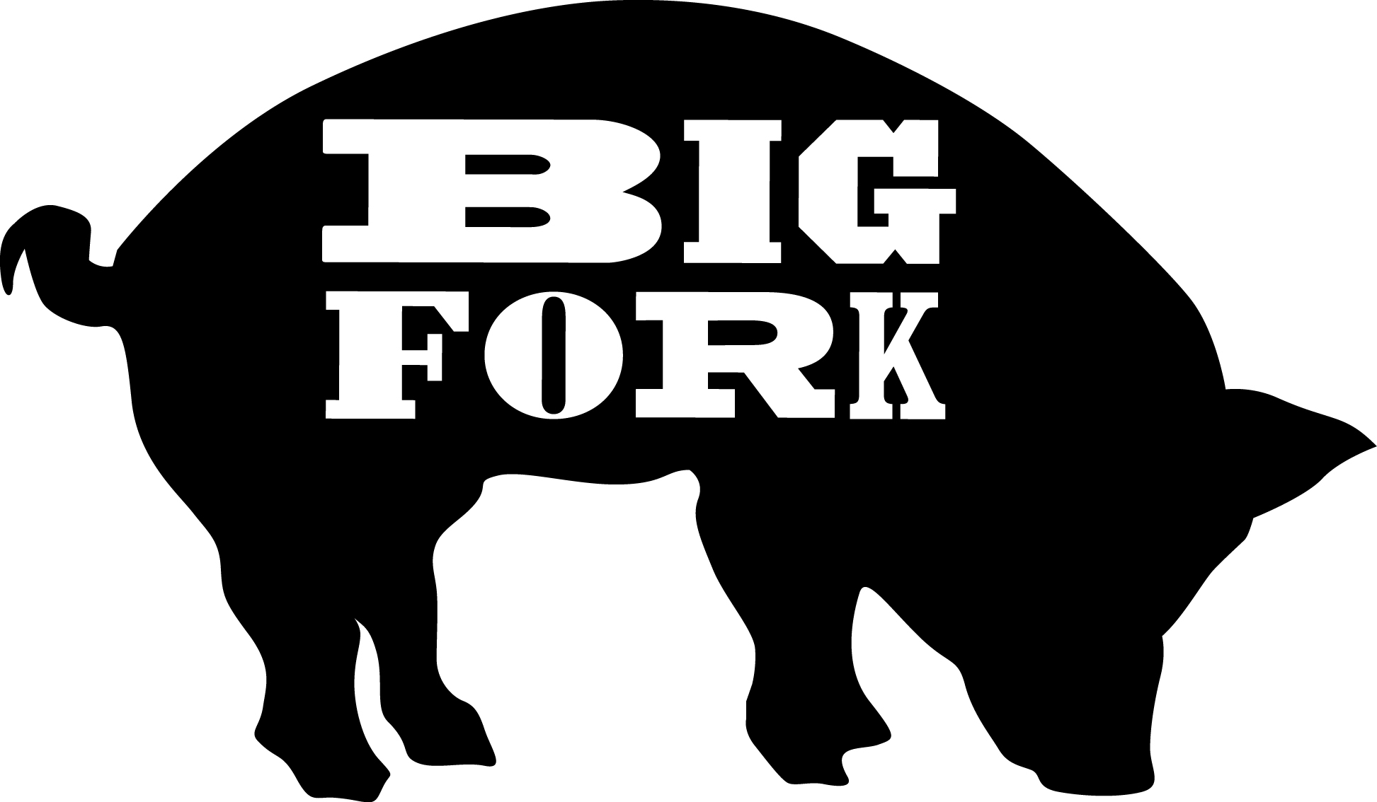
“Making Sausage Better with Bacon”

Dear Audubon Parents,

Big Fork is doing a fundraiser for the Class of 2016 at Audubon Elementary. Each pack of bacon sausage is $10.00. The Class of 2016 will receive $5 for each package you buy. The proceeds will go towards the 8th grade Washington DC trip.

The details are as follows:
- Attached is an order sheet
- The deadline to fill out the order sheet is Monday, Nov 16th
          - Make you checks written out to:
Catherine Tipping/Class of 2016
- The sausage pickup date is conveniently during report card pickup day, on November18th
- The sausage pickup location will be a Big Fork table display near the main office on the first floor.

About Big Fork:
Voted as one of the Best New Foods in America 2014 by Esquire Magazine, Big Fork Brands is a Chicago-based, family-owned company specializing in handcrafted, artisanal sausages using all-natural pork and nitrite-free hardwood smoked bacon. Our products are free of artificial flavors, preservatives, antibiotics, hormones, and gluten. We use hogs and chickens that are vegetarian fed and raised in the Midwest. All varieties of Big Fork sausages are a good source of protein and contain irresistibly robust flavor. We cram as much bacon as possible into every sausage and add little else. This simplicity lets the bacon flavor shine through so you get BIG flavor without the additives.

To learn more about Big Fork go to http://www.bigforkbrands.com/

Big Fork Sausage Order Form

Parent name:

Big Fork Sausage Flavors $10 / pack of 4 | Total
Hickory Applewood
All natural pork & cured bacon, naturally hardwood smoked
Cracked Black Pepper
Just like the Hickory & Applewood, with ample amounts of fresh black pepper
Maple & Brown Sugar
Designed for breakfast, sweet and savory, loaded with pure maple syrup
Aged Cheddar Cheese
Made with Wisconsin aged cheddar cheese, the perfect bacon pairing
Portabella
Our most unique sausage, made with roasted portabella mushrooms
Spicy – 3 Pepper
For the spicy lover, made with fresh jalapenos, crushed red chilies & habaneros
Chicken
Free-range chicken & nitrite-free bacon, amazing flavor without all the calories
SUBTOTAL:
(number of packs ordered)
TOTAL:
(multiply subtotal by $10)
- Please make checks payable to Catherine Tipping/Class of 2016.
- Return order form with check to child teacher by Monday, November 16th.
- Pick up will be on first floor, near office on Wednesday, November 18th, during Report Card Pick up.
- Keep a copy for your records.

