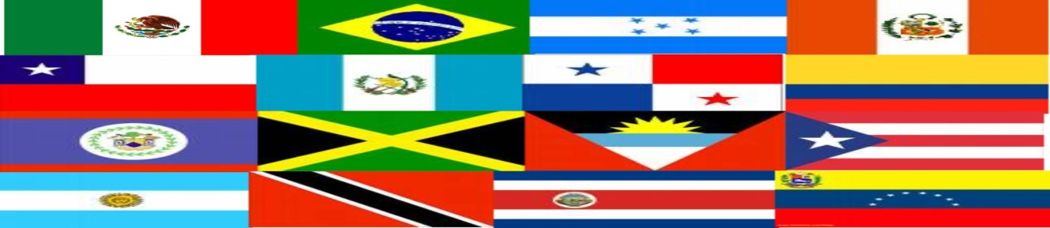
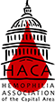 Hemophilia Association of the Capital Area
Invites Spanish speaking families to

“Celebrating Our Community - Bleeding Disorders Educational Conference: Education, Culture and Music”

Sunday, September 20th, 2015

Marriott at Metro Center
775 12th Street, NW
Washington, DC 20005

We are very pleased to offer our first educational program for the Spanish-speaking community with bleeding disorders. The main topics will be “Self-Advocacy” and “Support and Community: Essential Resources for Caregivers.” This is a great opportunity to learn more about these topics and to connect with other families with bleeding disorders.

Separate programs for children and adults. Childcare is available for children under the age of 6 years old. There also will be a wellness booth sponsored by Walgreens. There is no cost for this event. All presentations and discussions for adults will be in Spanish. Pre-registration is required. Parking is not available at the hotel but is available at several parking lots within walking distance of the hotel. HACA will reimburse parking fees for those who request reimbursement.

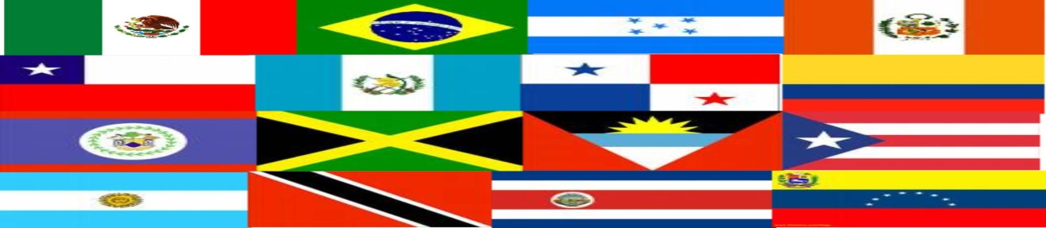

Program Agenda

Sunday, September 20th

9:00 – 9:30 Arrive at the program – Registration – Drop children at Childcare
Breakfast sponsored by Novo Nordisk

9:30 – 9:45 HACA Group Welcome
Karen Krzmarzick, Executive Director, HACA

9:45 – 10:00 Introductions and Ice-Breakers

10:00 – 10:45 Self-Advocacy
The topic addresses the practice of understanding your needs, developing a plan to meet them, and assertively communicating for success
Presented by Karla Zevallos, MA LSW; Bilingual Healthcare Educator, Baxter Bioscience

10:45 – 11:15 Break with Exhibitors

11:15 – 12:00 Support and Community: Essential Resources for Caregivers

Focused on caregivers and the challenges they face when caring for a loved one with hemophilia

Presented by ……, Novo Nordisk

12:00 – 1:00 Lunch sponsored by Baxter Bioscience

1:00– 2:30 Wrap-up and Hispanic Heritage Celebration: Trivia, games, prizes

2:30 All of us will head to “Fiesta DC 2015” - Pennsylvania Avenue, between 9th and 14th Streets, NW Washington, DC

To register Online: http://events.constantcontact.com/register/event?llr=lkxd96lab&oeidk=a07eayx42ozfac82edb
Email: admin@hacacares.org
Phone: 703-352-7641 (English speakers only)

HACA Bleeding Disorders Educational Conference and Hispanic Heritage Celebration
Family Registration Form
September 20, 2015

Family Last Name: _____________________________________________________________
Street Address: _________________________________________________
City: __________________ State:_________ Zip Code: _____________
Telephone: ____________________________________________________
Email: ______________________________________________________________

Adults Attending:
Name Do they have hemophilia, VWD or other?
______________________________________________________________________
______________________________________________________________________
______________________________________________________________________

Children Attending:
Name Age Do they have hemophilia, VWD or other?
______________________________________________________________________
______________________________________________________________________
______________________________________________________________________
______________________________________________________________________

Please list any food allergies or special instructions for your child/children:_________________________________________________________
____________________________________________________________________________________________________________________________________________________________

Please return this form by September 12th, 2015 to:
HACA
10560 Main Street, Suite 309
Fairfax, VA 22030
Questions? Please call HACA office at 703-352-7641

