A Toast to Betsy Labar

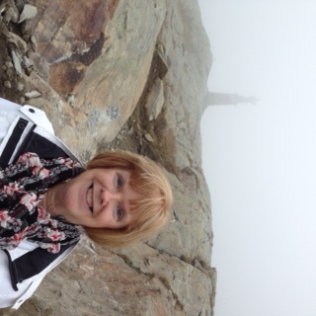
Betsy Labar, Belmont’s Special Events Manager since 2005, will retire at the end of June. Betsy has been with Belmont since 1995, when she was one of the first visitor center desk attendants when that facility opened. She eventually began helping with facility rentals like wedding receptions (all outdoors!) until taking over fulltime when the Studio Pavilion was about to open for public use.

Betsy also became the organizer and leader of members’ travel, leading museum groups on countless trips, including several to Europe to follow Gari Melchers’ own travels. She organized both day trips and overnighters to dozens of museums and historic sights. Anyone who ever traveled with her was grateful for the eye-opening mimosas that traditionally kicked off her bus trips!

Betsy was always looking for the next party to host and oversee. She organized numerous holiday events and special themed evenings, such as Mother’s Day teas, a celebration of Secretariat’s Triple Crown and a Valentines’ Sweetheart dinner. All of these brought both old and new Friends of Belmont together to enjoy the special ambiance of Belmont.

As a wedding planner, Betsy was without peer. Scores of brides relied on her calm hand in making sure all went well during nervous times. She built Belmont into a premier destination for not only weddings, but family celebrations and professional events.

We will miss her enthusiasm and positive outlook. She got everyone excited about each event, and never failed to fill the seats. We will keep one open for her, so the next time, she will be the pampered guest!

David Berreth
Director

