**Tisha B'Av Services with Temple Emanuel Sinai**

*A community worship experience with the reading of the Book of Lamentations (Eicha)*

**Saturday, July 25, 2015**

at Congregation Beth Israel

**7-8:00 p.m.** - Dairy potluck pre-fast dinner at the Fellman’s. Please contact Reena Slovin to RSVP for the dinner

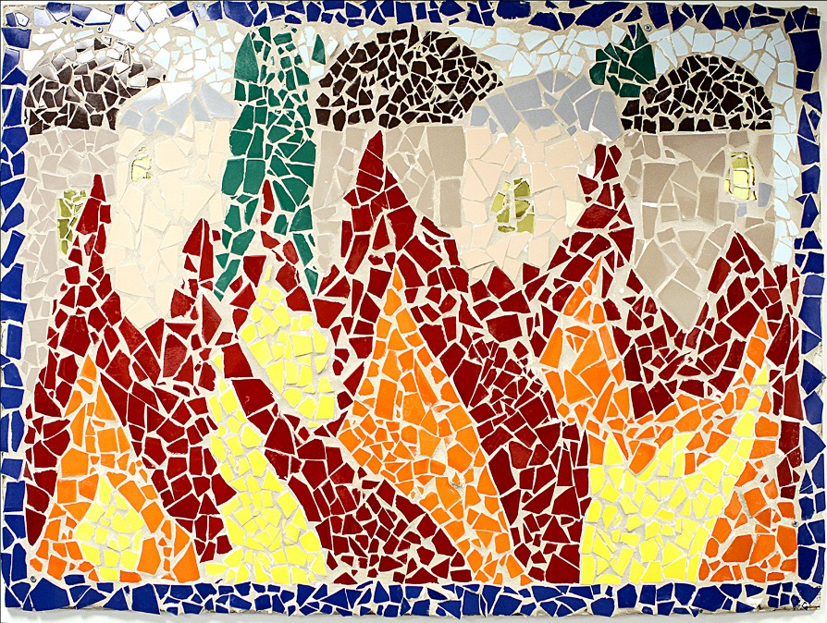[reenaslovin@gmail.com](mailto:reenaslovin@gmail.com)

**8:14 p.m.** - Tisha B’Av fast begins. We will meet in the library to sing songs and set the somber tone of the evening

**9:05 p.m.** - Maariv and the chanting of Eicha. Please bring your own flashlights and candles

**Sunday, July 26th**

**8:30 a.m.** - Morning services (with Torah reading and Eicha)

**2:00 p.m**. - Mincha/afternoon services *(No 7 p.m. Service)*

**9:04 p.m.** -Fast Ends

*Tisha B'Av,* the Fast of the Ninth of Av, is a day of mourning to commemorate the many tragedies that have befallen the Jewish people, many of which have occurred on the ninth of Av. This day is traditionally observed through fasting, observing mourning rituals (not wearing leather) and the reading of the Book of Lamentations.