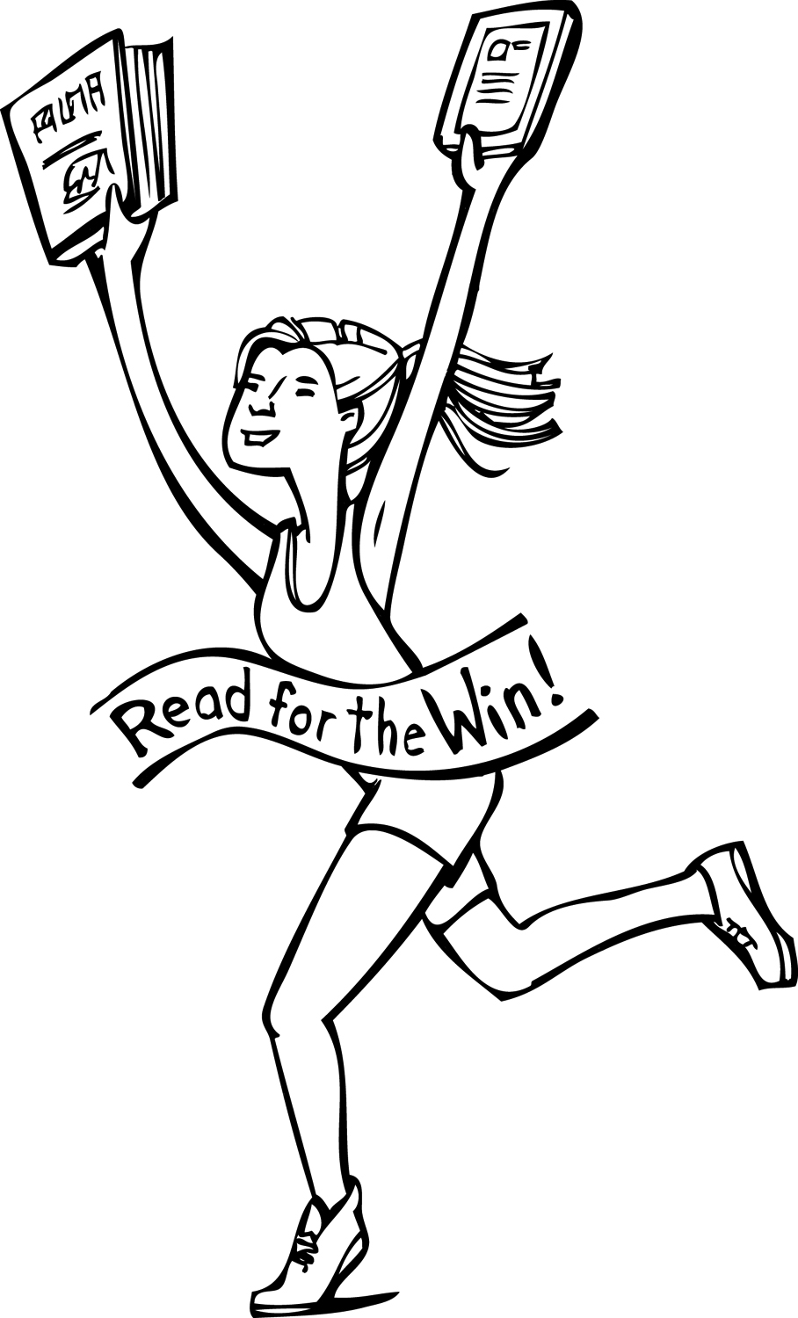
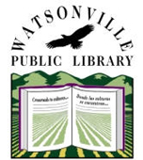
Watsonville Public Library
Children’s Bookmark Contest
For ages 3-12

Calling all artists! Our Summer Reading Program "Read for the Win" needs a bookmark.
Create your design below and turn in to the library by May 21, 2016. Entries will be displayed at the library. The Winning bookmarks will be distributed at the library.

Rules:
- Read for the Win is our 2016 Summer Reading Theme. It's about celebrating our achievements in reading, sports and other activities.
- Use the space provided on this entry form to draw your original design any way you would like. Please do not write your name on the bookmark.
- Use any 2D art medium (crayons, markers, colored pencils, etc.)
- One winner in each age group will be chosen: 3-5, 6-8, and 9-12
- Winners will be notified by phone and will be presented with a certificate and a prize at our Summer Reading kick-off event: June 4th, from 12-2pm.

Name: ___________________________________ Age: ___________________
Phone: ______________________ School and Grade: _________________________
All entries become property of Watsonville Public Library and may be reproduced for public distribution, displayed in the library, posted to the library’s website, or used for other publicity purposes.
Parent signature: ________________________________________________________________
275 Main St. Suite 100 • Watsonville, CA 95076 • (831) 768-3400 • http://cityofwatsonville.org/public-library

