Making Proud Choices & Parents Matter
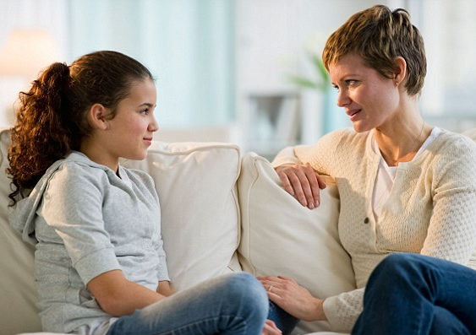
Two FREE Classes:

- Youth with disabilities (lunch included)
- Parents of youth with disabilities (dinner included)
Join us for two half-day comprehensive sexuality education classes including relationship education for youth with disabilities, ages 11 and up, along with a workshop for parents of youth with disabilities on how to be your child’s sexuality educator.

Youth Classes:
Monday & Tuesday December 21 & 22 12:30 - 4:30 pm
Parents Class (youth can stay):
Monday, December 21 5:00 - 7:00 pm

IndependenceFirst
540 S. 1st St. Milwaukee

For more information or to request accommodations, contact Alie Kriofske.
Call 414-226-8112 V/Relay
Reasonable Accommodations IndependenceFirst is committed to providing the highest degree of accessibility when offering agency-sponsored events. Please notify Alie at 414-226-8112 or akriofske@independencefirst.org with your disability-related accommodation requests by December 10. We will do our best to honor accommodation requests made after this date. | Environmental Chemical Sensitivities  For the safety and comfort of those with chemical and environmental sensitivities, IndependenceFirst requests that when attending agency-sponsored events, please refrain from using any perfumed products such as scented soaps, deodorants, perfumes, colognes and heavily scented fabric softeners. To maintain a smoke-free environment, please also refrain from smoking in paths of travel and doorways.
Email: akriofske@independencefirst.org

