
Moses Lake Area Agriculture Hall of Fame

The Moses Lake Area Agriculture Hall of Fame was formed in the Year 2010 to recognize and honor distinguished individuals that have made significant contributions to the agricultural community in the Greater Moses Lake Area. Nominees from Grant County will be considered for this prestigious award.

The Moses Lake Chamber of Commerce has proudly created an Agriculture Hall of Fame Selection Committee that is comprised of quality individual representatives of our agriculture industry, and has chartered them with the honorable task of reviewing all nomination submittals. To date, five individuals have been inducted into the Hall of Fame. Induction candidates are selected based on their contributions to the industry and their support of their community. Candidates are recognized by their peers for not only their dedication, generosity, and selflessness, but also their demonstrated achievements, noteworthy expertise, and creative innovations that often provide a legacy of impactful results and lasting benefit to the overall enhancement of the local agricultural industry and community at large. Farmers, growers, ranchers, and owners/ employees of agribusiness firms are all eligible for nomination as either individuals and/or families.
The Ag Hall of Fame inductions will be presented at the Moses Lake Chamber of Commerce Annual Banquet in October 2016 at Pillar Rock Grill at the Moses Lake Golf Club.

Deadline for applications is July 2016.

Moses Lake Area Agriculture Hall of Fame Intent to Nominate Nominee’s Name: _
Mailing Address:
Street Address: ___
Nominee’s Phone: Fax:
E-Mail: Date of Birth: Birthplace: __
Date of Death (if deceased): ____
Nominator’s Name:
Phone: Fax:
E-Mail:
Nominee’s Family Contact: _
Phone: Fax:
E-Mail:

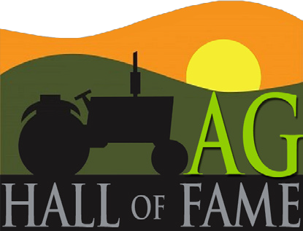

Nomination Requirements

1. Nomination Form Name of Nominee Photo of Nominee
The Nominator and Relation
Date Submitted

2. Years of Community and Agriculture Service
Please list no more than twenty (20) organizations and service the Nominee has participated in to enhance our agriculture community. (E.g. commissions, associations, community service, volunteer activities and events, etc.)

Sample: Cattleman’s Association/25years+/ Served as Board
Director 89-92, auction organizer, and fundraising chair 1993.

3. Brief Bio of Nominee
Please provide (1-2 pages) of background information profiling the Nominee’s family history and childhood experiences, including the geographic region of the Nominee’s upbringing. Be sure to emphasize any and all character traits and attributes unique to the Nominee and discuss personal interests and
Values that would help create a Nominee signature story. As the Nominator, it is imperative to include your personal sentiments and justifications to support the selection of your Nominee into the Moses Lake Area Agriculture Hall of Fame.

4. Attachments (not to exceed 10 pages)
Please provide photos, newspaper, and/or magazine clips, individual letters of recognition and support special awards, event photos, etc.

If you are unable to complete any of these listed requirements please contact the Chamber by emailing information@moseslake.com or (509) 765-7888 and we will do our best to assist you in completing the applications.

Mail completed nomination forms to:
Moses Lake Chamber of Commerce
324 S Pioneer Way, Moses Lake, WA 98837
For more information, call (509) 765-7888 or email information@moseslake.com

