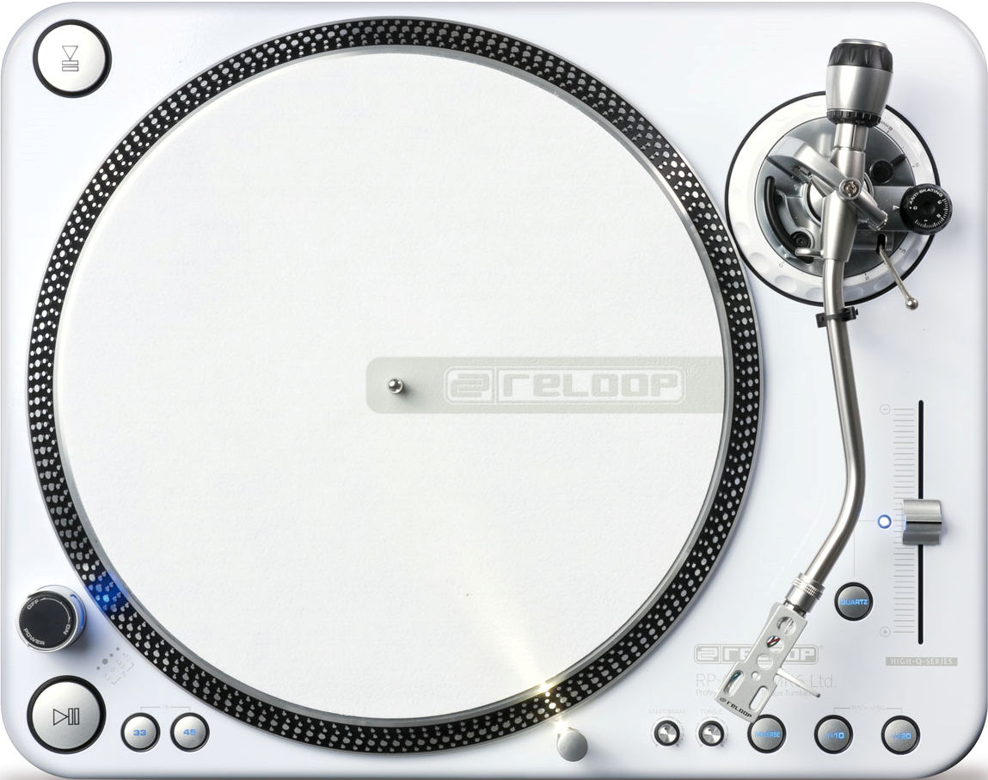
Auditions starting Wednesday Jan. 21st
Join the Radio NOW
Sign up at the Radio

