SUMMER STAGES
2015

Disability Network Summer Program
1705 S. Saginaw Rd

April 2015

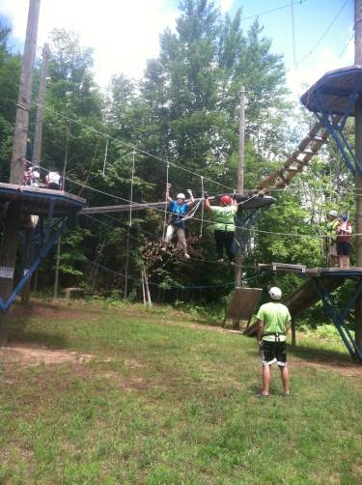Our Thirteenth annual Summer STAGES program will soon begin. See the attached information for the general plan. Remember most activity are single events, you can pick and choose the ones you want to attend. However, anyone applying for the work program at Camp Fish Tales will need to make the commitment for the majority of the 10 weeks. Please read that information carefully so you have a good idea of what to expect.

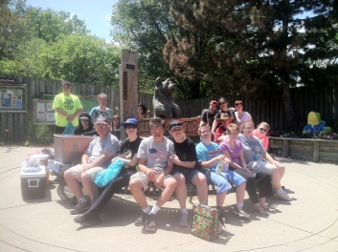Look over the list that follows and choose the activities that you think you will want to be involved in and fill out your registration form. Your response will help us determine the group size to expect at each event. If you are honest with your expectation we will have a good idea of how to plan for each event. Signing up for an event does not mean you can’t change your mind if something comes up or you get a job that interferes. It gives us an idea of interest. Registration for most events stays open until the event occurs. However there are a few activities may have limited participation, so it is important to check those things you would like to do.

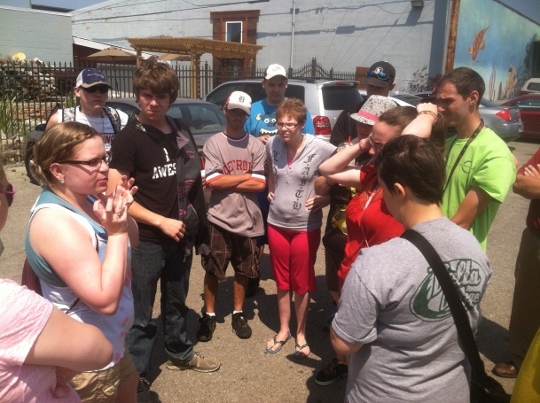The calendar enclosed is not the final calendar of the summer, not all events have exact times and some times listed are tentative and not yet confirmed. We also we may add or subtract events as the summer goes on. However, this calendar contains the majority of our activities. If we find some other cool activities to add we will communicate those to everyone who signs up. Those who sign up will get a letter with very specific details about when and where to meet for each event. This will come in two parts, a letter for each half of the summer.

Please register by filling out & returning the enclosed form by June 5.
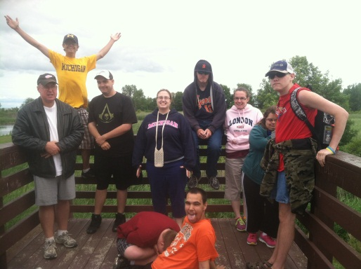
Transportation is always a challenge. Since our program is intended to build independent living skills, we feel it’s important for the student and his/her family to take the primary responsibility for making transportation arrangements. The STAGES staff will do what we can to assist in your travel needs. But do not assume your transportation will be taken care of automatically. If you choose to use the city or county bus system, we will provide assistance with tickets. It is your job to ask ahead of time. We will have a meeting place in both Midland and Bay City. When the meeting place is not the site of the activity we will provide transportation from the meeting site to the activity and back. In Midland, the most common meeting location is DNMM office at 1705 South Saginaw. The common meeting place in Bay City will be at the Washington Street (Bay) Metro Station.(WSMS). You will need to let us know if you plan to meet us there as we will not just wait unless we expect students. Parental assistance with transportation would be greatly appreciated, especially for the larger events. If you have any questions please call 989 835-4041.

Business Focus:

1) Paid work experience at Camp Fish Tales near Pinconning – general cleaning; work one day each week for about 2 hours. Lunch is provided. Must be 14 years and committed to work 9 weeks to participate in this activity. This is limited to 16 kids. Please understand this is a work experience not a full-fledged job. We will be at the camp about 3-4 hours, but will work only a couple of those hours. At the end of the summer you will get a stipend (roughly based on two hours of work each time) depending on the number of times you worked. You will not get a W-2.
2) Job tours – provides a look at the careers connected with a specific business. Each business tour is a single event. We will provide exposure to several job areas. Job tours are being set now but are not confirmed as to the when and where. That info will follow. On the calendar the June 15 tour will be at Shirts Mugs and More in Bay City. Meet at DNMM at 3:30 and pick up at 6:00. Bay City meet at the business at 4:00 pick up at 5:30. Other tours currently listed are June 23, & 30, July 7, August 11.

Recreation Focus.

- Hang Out – Weekly drop-in event; Wednesday from 2:00 to 4:00 p.m. (most weeks). No registration needed. Friends welcome. The location of this weekly activity will be the skill cite at 3921 Todd street; Midland. There will be a 1:30 pick up time in Bay City at WSMS
- Picnics & other recreational activities are scheduled throughout the summer. The opening picnic will be June 11, Thursday, at Plymouth Park Shelter H, in Midland. Swimming available for a cost. Picnic from 1:30 – 2:00. You will notice some other picnics or a day at the park on the calendar. More will be added likely.
- Volunteer Opportunity at a local Assisted Living facility. June 16 We will do a project with the residents who make this their home and maybe a project for the home itself. Meet at DNMM or WSMS (Bay City) at 9:30 and the return rides may be made for 12:30 in both cities.
- Relationship Safety discussions -- June 24, July 8, & 22; Aug 5 & 19. –This is in connection with the ShelterHouse of Midland and the discussions will be facilitated by Audra Johnson. People sometimes get used by others in a variety of ways. These discussions will give some help in avoiding these situations.
- Bike riding event. June 25, July 23 & August 13. On June 19 – meet at 10:00 at the Hockey Rink in Emerson Park in Midland. If you live outside Midland County let us know of your interest and we will help work out your meeting place. July 26 meet at the DNMM office at 9:30 or Bike Trail parking area near water treatment plant on Patterson Rd in Bay City at 10:00. August 12 we will ride Saginaw Valley Trail, meeting at DNMM at 9:30. Bay City riders we will figure out as the time draws near
- River Roar boat races in Bay City - June 26 Meet at the DN/MM @ 11:00 AM return at 4:00 PM. Vendors will be setting up booths for snacks. We will have beverages. Bay City students meet at the helicopter at 11:30 and Bay City pick up time is 3:15. Midland bus appointments can be for 4 pm. Money is optional for this event. We will provide a picnic lunch for the participants.
- Craft activity. -- June 29 – This is a work in progress but we will do some crafts together at the Skill Cite in Midland. We will meet at the Skill CITE at 10:00 and pick up can be made for 12:00 noon. In Bay City the meeting location is the WSMS at 9:30 and we will return there by 12:30. Snacks available but not lunch.
- Adventure Day at Camp Fowler. July 9 7:30 to 4:30 High Ropes & Horse Back riding will be the primary activities along with some team building activities to fill our day. Interested participants will be sent further permission forms. Please note: To avoid last minute cancellations and late uncertainty in who is really planning to attend, we will require a $15 deposit along with the special forms that will need to be signed. The $15 will be returned when you come the event day. If we have unnecessary no-shows, we end up paying for empty spots and cheating others who want to go out of the opportunity. Maximum for this event is 20. The $15 deposit will demonstrate the needed level of commitment.
- Zoo Trip Potter Park Zoo in Lansing – July 14. Meet meeting time in both Midland and Bay City will be at 9:00. Return time will be about 4:00. A picnic lunch will be provided. Admission to the Zoo will be $7. DNMM will pay the remaining amount.
- ShelterHouse Midland Volunteer project. We will meet at 10:00 at DNMM (9:30 at WSMS Bay City) for a volunteer and educational day at the ShelterHouse. We Will be back at DNMM at 3:00 pm or Bay city at 3:30. An opportunity to help out another human service organization and learn in the process.
- Overnight at Camp Fish Tales July 27 & 28 – The camp is located between Linwood and Pinconning. This is about a 24 hr. stay with a lot of fun activities. More details will be given later but it is from abut 2:00 pm Monday to 2:00 pm Tuesday. Parents are asked to car-pool kids to the camp and back. By special arrangement, DNMM may be able to assist some students with rides. No cost.
- Bay City River boat ride. Princess Winona July 29. 8:30 – 2:00 Limit 17.
The Princess Winona is a cruise from Downtown Bay City to the Bay and back. Family can also get free tickets on their own from Bay city Boat Lines and join us if they want.
- Bowling – August 4 -- Place is TBD – time approx.. 1:00 to 3:00 pm.
- Roller Skating at Midland Roller arena. 2:00 – 4:00. Cost $5 plus skates if you need them. There are also concessions if desired. Meet & pick up are at Roller arena for Midland County. Bay will be at WSMS at 1:30 and 4:30.
- Road Rally. August 20 – A road rally is a very fun scavenger hunt around town. This is organized by one of our parents and other parental support in terms of volunteer drivers will be helpful for this event. Since we are in teams additional drivers are needed.
- Loons Baseball Game. August 25. Cost $5. We will be in Pier 47 seating area again. This is an evening game so our meeting time will be around 6:15. This will be our closing activity of the sum mer.

We are very excited about our program this summer. We have some “admission required” events again this year. Please do not let money be the only reason you are not attending some event, Talk with a DNMM staff member prior to the event and we may be able to assist. Money has become tighter in recent years so we will be subsidizing less than some past years. Yet we can assist students who need that assistance if they request it. Tax deductible donations toward general program costs are always welcome. If you have any questions, want more details, or have some additional summer ideas, feel free to call at 989-835-4041, or 800-782-4160. Remember, register by June 5 to assure your place in the program.

Do you know of a friend who might want to attend. Let us know their contact info and we will send them information.

The DN/MM S.T.A.G.E.S. Team

Lowell Gisel - Program Coordinator
Nora Maza; Tim Ogden; Lara Beth Sullivan; & Mya Barnwell

Please fill out the front and back of this page and return it to the Disability Network of Mid-Michigan: 1705 Saginaw Rd; Midland, MI 48640
Please return form by May 30, 2013

Summer With the DN/MM!

Registration Form
Due by June 5th

Student’s Name ___________________________________
Parent / Guardian name_____________________________
Address__________________________________________
City _____________________ Zip Code ____________
Day phone / Eve phone______________________________
Best Email address to update your family re additions or changes _________________________________________________________
Have you been part of DNMM programs since last summer? Yes __ No __
Mark all of the activities in which you wish to participate. You can do as much or as little as you want. This info assists us in planning.

Business Program
___ Work at Camp Fish Tales June 9 – August 22 (Limit 16)

Job Tours * Students should bring money for lunch stop following Job tour
___ June 15 – Shirts Mugs More
___ June 23 – TBD
___ June 30 – Thelen Auto group
___ July 7 – TBD
___ Aug 11 – Greater Michigan Construction Academy

Recreation Program
___ Picnic & Hang-out at Plymouth Park June 11
Bring swim gear if desired. Admission for swimming.
___ Hang Outs at the Skill Cite, 3921 Todd St. Midland
Wednesdays from 2-4 pm beginning June 10
___ Relationship Safety activities June 24, July 8, 22, Aug 5 & 19.
Wednesday mornings at 10-11:30
___ Volunteer at local Assisted Living home – June 16
___ Fun at the Park – July 15
Bike Riding Events
____ June 25 – Midland
____ July 23 – Bay City
____ August 13 Saginaw County
___ River Roar Boat Races in Bay City – June 26
___ Craft Activity @ Skill Cite – June 29
___ Adventure Trip to The Fowler Center July 9 -- $15 deposit refundable when you attend. Special permission form will be sent.
___ ShelterHouse of Midland volunteer & education day – July 16
___ Overnight camp at Camp Fish Tales. July 27 - 28
___ Bay City River boat ride. July 29
___ Bowling -- Aug 4
___ Roller Skating, Midland Roll-arena – August 14
___ Road Rally – August 20
___ Loons Baseball Game August 25 6:15 cost $5
Transportation Assistance
If you are willing to be called to help provide transportation please indicate below. Feel free to tell us with what events you would most like to help
____ I am available to help with driving. Please call me when there is a need to check on my availability. Please indicate if you are available certain days or for particular events.
____ I would like to see a Job tour at the following business or career pathway. Please identify a business or kind of job you would be interested in seeing
____________________ _______________________
Please register by filling out & returning the enclosed form June 5.

