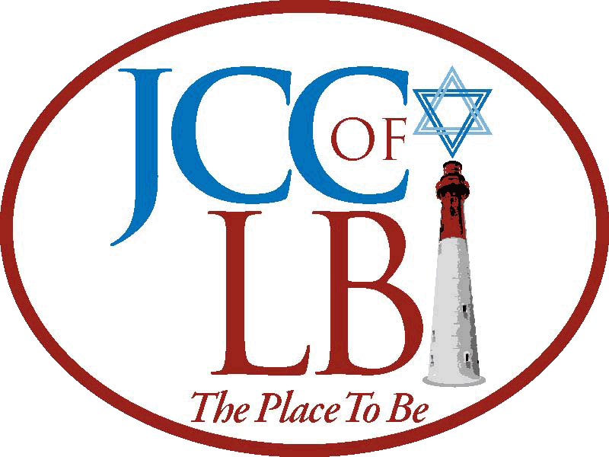
KIDDUSH
SPONSORSHIP

If you would like to sponsor a Saturday Kiddush please fill out the form below and return it to the
Jewish Community Center of LBI along with a check made payable to JCC of LBI

Jewish Community Center of LBI
2411 Long Beach Blvd.
Spray Beach, NJ 08008
Any questions please Contact Lynn Berkowitz through the office at 609-492-4090
----------------------------------------------------------------------------------------------------
Yes, I/we would like to sponsor a Saturday Morning Kiddush __________________ (date)

____$150 minimum contribution
____$350 Tuna salad, Egg salad & Whitefish platter
2 kinds of cream cheese
2 Salads – Health & Israeli
Bagels
Cookies & Cake tray or 1 Fruits & Cookie tray
____$500 Tuna salad, Egg salad, Whitefish & Lox platter
2 kinds of cream cheese
2 Salads – Health & Israeli
Bagels
Cookies & Cake tray or 1 Fruits & Cookie tray
Celebration cake
$_____ Other
(Payment must be received in advance of the date)

- Printed acknowledgement on the Kiddush table, in
the Shabbat Flyer and JCC bulletin.
- Verbal, public acknowledgement (thank you)
from the bimah during services.

Enclosed is my/our check for $__________________

We are sponsoring this Kiddush in celebration of:
_____Anniversary of _______________________________________
_____Baby naming of ______________________________________
_____Bar/Bat Mitzvah of ____________________________________
_____Birthday of __________________________________________
_____Engagement/wedding of _______________________________
_____In memory of, or to mark the yahrzeit of ___________________
_____Other, specify: graduation, safe return, recovery, honoring a
teacher, etc. __________________________________________

Contact Information:
Name(s) ___________________________________________________
Address ____________________________________________________
Telephone __________________ Email __________________________

