


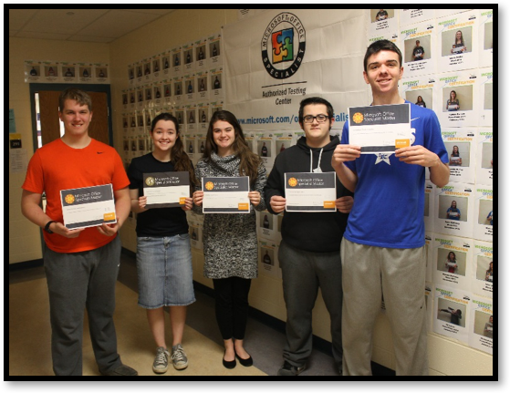



FREE MOS and MTA Vouchers!
That's right! Your students can attend the STLP State Championship at Rupp Arena in Lexington on April 22 and take MOS and MTA exams for FREE. What a great opportunity for all of your students to take an exam(s) and not affect your exam inventory!

Kentucky's STLP State Championship - Scroll about half way down the page to find information on the Imagine Academy Certi-palooza event. Then go to the following link to pre-register your student(s) to take exams: Pre-registration for the Imagine Academy Certi-palooza - go to the third page on the registration to locate this activity.

More Training Opportunities Scheduled!

Are you new to Imagine Academy or just trying to figure out how to navigate the site to access the curriculum and resources made available to you at no charge? Register for one of these training events:
March 23, 4-6 p.m., Allen Central High School, Eastern
or
March 31, 4-6 p.m., Carroll County ATC, Carrollton
KYIA webpage
Microsoft IA Blog
Microsoft EduCast Webinar Series
KY’s Certiport webpage
Follow KY IA on Twitter
@KYITAcademy
Laura Raganas, KY IA Program Manager laura.raganas@education.ky.gov
Megan Hochstatter, Microsoft Deployment Manager
v-mehoch@microsoft.com
Ann Schreck, Certiport Deployment Manager
ann.schreck@pearson.com

KY Imagine Academy Newsletter
Data:
We now have 260 high schools and ATCs registered for Imagine Academy in Kentucky!
Make sure you are also a testing site with Certiport so your students can certify!
Stay Connected:

March 15, 2016
Planning and Aligning Imagine Academy Curriculum for Next Year
Here is a great chart that will help as you plan and align your curriculum for next fall:

Office Application | MOAC Curriculum Download | Online Learning Course | Exam
Excel 2013 | MOAC MOS 77-420: Excel 2013 | Course 70148: Microsoft 2013 Excel Essentials (Estimated time for completion 3.84 hours – excluding labs and assessments) | MOS 77-420
Word 2013 | MOAC MOS 77-418: Word 2013 | Course 70158: Microsoft 2013 Word Essentials (Estimated time for completion 2.73 hours – excluding labs and assessments) | MOS 77-418
PowerPoint 2013 | MOAC MOS 77-422: PowerPoint 2013 | Course 70154: Microsoft 2013 PowerPoint Essentials (Estimated time for completion 3.67 hours – excluding labs and assessments) | MOS 77-422
Here are some URL’s to save to make navigation easier:
- Imagine Academy member site (where you can find these and additional resources):
https://member.itacademy.microsoft.com/
- Online Learning administrator site (must activate first from the MSIA member site): https://imagineacademy.microsoft.com/administration
- Online Learning learner site: http://imagineacademy.microsoft.com
- Get started videos: http://aka.ms/Aue3bf



Certiport Tips and Tricks
Stay informed as a Certified Authorized Testing Center (CATC). Certiport regularly delivers a comprehensive newsletter covering topics such as critical system and exam updates, highlights on recent and upcoming events, teacher/student spotlights, and other information to help you and your students have an exceptional exam experience. Sign up for the CATC newsletter by clicking here and filling out the associated form.

Top 10 Checks for the Testing Season

It's almost time to begin testing again. In preparation for the upcoming testing season, we want to help ensure that your Certiport Authorized Testing Center (CATC) is prepared for test delivery prior to administering exams. Over the past two weeks, we've shared our top 10 administrative checks and our top 10 technical checks.

This week we would like to encourage you to check out our CATC Test Prep page to review helpful tips and tricks to foster the most compatible, error-free testing environment. If you have other questions be sure to take a look at our FAQ and Common Support Issues pages for additional support materials.
Certiport has live webinar trainings available:
Account Management webinars are every Wednesday at 11 a.m. ET and 4 p.m. ET. Click on the time for which you would like to register.
Console 8 webinars are every Thursday at 11 a.m. ET and 4 p.m. ET. Click on the time for which you would like to register.

Left: Classroom wall of fame
Right: MOS Master Certified students by hallway wall of fame
Story by Johnny Sue Bauer, Simon Kenton High teacher
Simon Kenton is well on the way to having another record year for MOS Certifications. I am very proud of the success rate with our students. Rarely do any of them fail and when they do they usually pass on the retest. We have over 175 certifications so far. Last year we had 277 certifications and we are hoping to top that this year. We test students for Word, Excel, PowerPoint, Access, One Note, and Word Expert, and will be doing our first Excel Expert soon. This year we have five students who have obtained master level certifications.
To prepare students to be successful, I have used the Shelly Cashman series textbooks and GMetrix software. I have been MOS testing students for over 16 years, the last four years here at Simon Kenton. I have always used this method of preparation because I have found it to be the most successful combination. On March 31, I will be attending the training at Carroll County ATC to learn how to begin integrating the Imagine Academy curriculum into what we have been doing. I also believe that a teacher should be MOS certified in the areas in which they are preparing their students so they can better instruct the students on the skills required to pass. I have taken all of the tests and recently passed the Microsoft Certified Educator.
When students pass certification, we take their picture with their certificate and display it in the business hallway. Another picture of them goes in the individual classroom, and we also post their success on Simon Kenton’s MOS web page (click on the link to see their progress) and email the faculty so their teachers know of their success. Students love looking at the photos. I really enjoy seeing the expression on the students’ faces when they pass their first certification. They are really so proud of their accomplishment. They always want to do more after that first one.
I also tell the students the benefits of certification as it relates to the workplace and college. Many students have told me about the classes they don’t have to take at college because of their certifications and the ones who have gotten jobs over other candidates due to their skill level.
“Ms. Bauer has been very encouraging to us over the course of this year. She keeps pushing us to take more tests because she sees our potential to succeed. My sophomore year, I passed the Word, Excel, and PowerPoint certifications, and this year, my senior year, I have already passed the Access, Word Expert Parts 1 and 2, and OneNote certifications, and am currently working towards passing the Excel Expert certifications. It’s really satisfying to see my picture and certificate go up on the wall each time I pass a different test and for achieving the master status, and knowing all my hard work has paid off. I also think it’s great that all of my peers have been successful in these certifications as well. It makes me proud to walk in to class every day and see the pictures of people who have passed different certifications fill up a wall and wrap around the corner. There truly are strength in numbers.” - Katie Taylor, MOS Master
“My certifications were definitely worth the time I spent working towards them. In two years I became certified in PowerPoint, Excel, Word (Expert), One Note and Access. The skills I have acquired are convenient in any project I encounter. The only inconvenience is that now my family members ask me for help with all their Microsoft-related problems.” - Kathryn Johnson, MOS Master
“It’s a big accomplishment in my small world.” Mitchell Kreidenweis
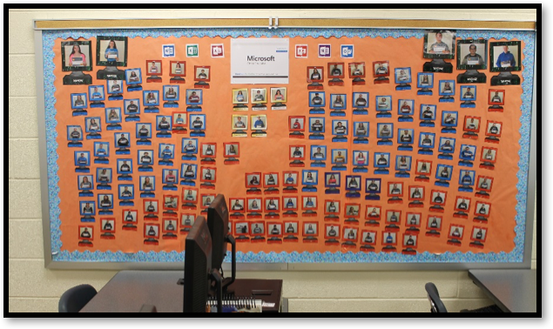

Simon Kenton High School
Spotlight:
Data Points for February:
The number of schools signed up for membership: 260
The number of registered testing centers: 248
The number of Excel certifications for the month: 163
The number of Excel certification year-to-date: 950
The number of MTA certifications for the month: 3
The number of MTA certifications year-to-date: 102
The number of online courses started: 29,381
The number of online courses completed: 8,564
The top 10 certifying sites:
1. Clark County ATC | 6. Highlands High, Fort Thomas Independent
2. Dixie Heights High, Kenton County | 7. Paul Laurence Dunbar High, Fayette County
3. Breckinridge County ATC | 8. Fern Creek High, Jefferson County
4. Larry Ryle High, Boone County | 9. Mayfield/Graves County ATC
5. Simon Kenton High, Kenton County | 10. Hart County High and Franklin-Simpson High (tie)
Is your school listed here?

School | Name
Marion County High | Dylan Tungate
Dixie Heights High | Michael Smeltzer
Pulaski County High | Mike Crowhurst
Simon Kenton High | Katelyn Taylor
Simon Kenton High | Christopher Welch
Simon Kenton High | Kathryn Johnson
Simon Kenton High | Johnathan Hawkins
Montgomery County ATC | Greyson Cox
Simon Kenton High | James Kreidenweis

School | Name
Beechwood High School | Logan Hamm
Dixie Heights High School | Miles Spurlock
Dixie Heights High School | James Fussinger
Dixie Heights High School | Andrew Perry
Livingston Central High School | Kaylin Travis

KDE’s KY IA Website is Now Updated!
Check out the Microsoft Resources folder and the Certiport Resources folder - they both have lots of “how to” documents that will help you navigate the Imagine Academy site. There is also a webinar available: “Webinar for the New Imagine Academy website” that you may want to watch.
MOS Master Certifications

