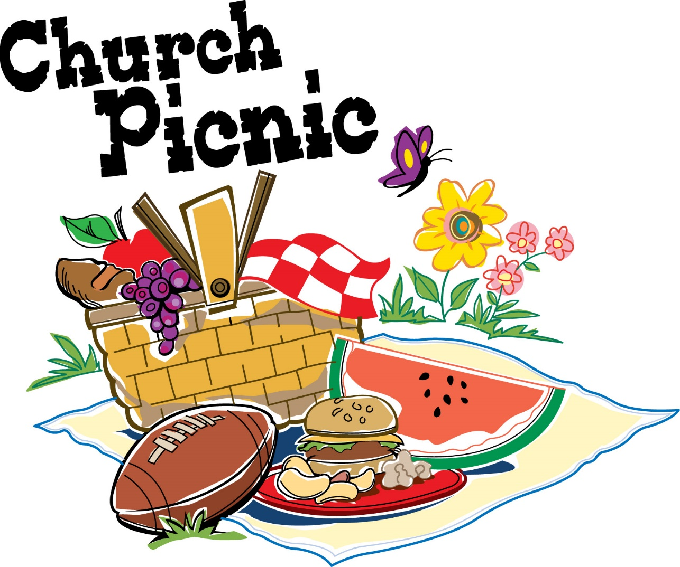

Sunday, June 5th

following Worship Service at

Historical Hopewell Church

FOOD ~ FUN ~ FELLOWSHIP

FOR THE WHOLE FAMILY

***More details forthcoming***