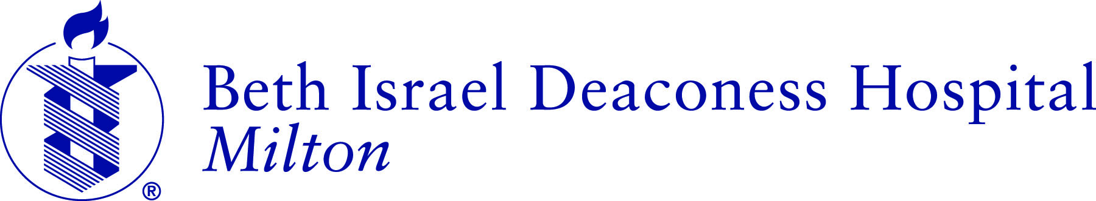

April 8, 2016
FOR IMMEDIATE RELEASE
Editorial Contact:
Robert McCrystal
Director of Communications
617-313-1590
robert_mccrystal@miltonhospital.org

Beth Israel Deaconess Hospital-Milton Offers Community Health Grants
Grant applications due May 6
Milton, MA, April 8, 2016 – Beth Israel Deaconess Hospital-Milton (BID-Milton) is offering mini-grants in amounts ranging from $500 up to $1,500 to local service agencies, non-profit organizations, Boards of Health, coalitions and community groups to address specific community health needs outlined in the hospital’s 2014 Community Health Needs Assessment.
Last year the hospital provided $9,000 in mini-grants to seven local organizations, including Milton High School, Girl Power, Joanna’s Place, Point Webster Middle School, Randolph Senior Center, South Shore YMCA and Quincy Public Schools. Grant applications are available through the hospital, and applicants should submit proposals which use proven or promising practices to improve primary care, disease prevention and/or health promotion for vulnerable populations with a focus on at least one of the following issue priorities:
- Provide access to affordable, community-based medical or preventive services, particularly for seniors;
- Offer educational programs and/or screenings to address chronic disease prevention and education that impacts vulnerable populations;
- Increase awareness of substance abuse as a growing health problem with a focus on education and prevention;
- Enhance community knowledge of mental health as a primary health issue and promote available mental health resources and supports;
- Develop programming that addresses health education around obesity and nutrition;
- Improve access to care by promoting existing public transportation options.
Applications must be for programs in BID-Milton’s market area of Milton, Randolph, Quincy, Dorchester, Hyde Park, Canton, Braintree or Weymouth, and are due Friday, May 6.
Grant applications may be downloaded from the hospital’s website at www.bidmilton.org. For more information call Robert McCrystal, director of communications, at 617-313-1590.
(-END-)

