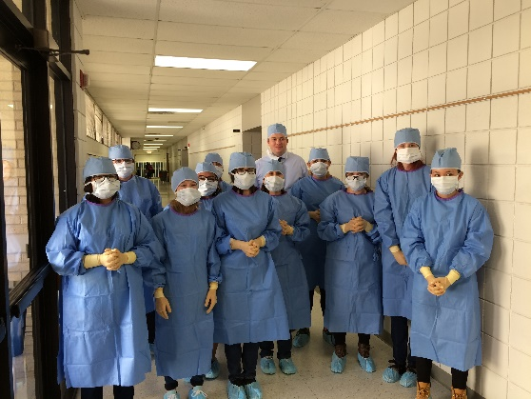
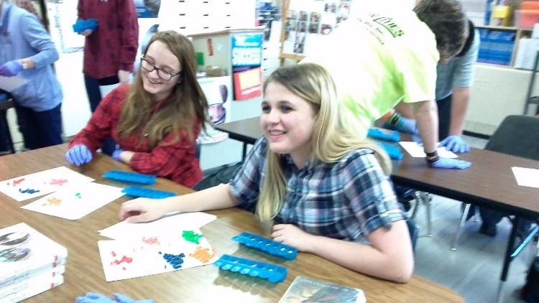
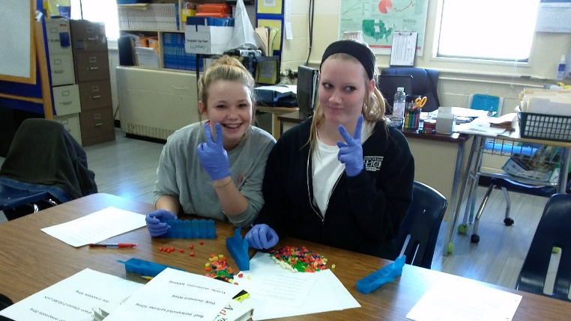
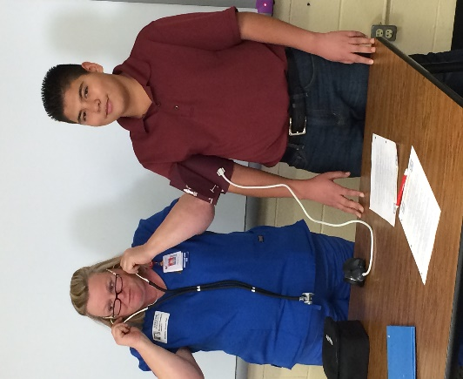
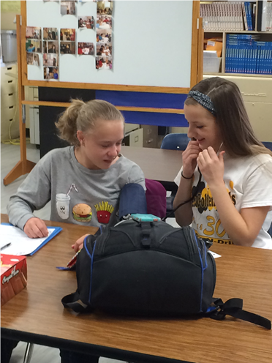
Club Scrub is an after school program designed to spark interest in health-related careers among 7th, 8^{th, and} 9th grade students through informative, hands-on activities.
JOIN NEXT YEAR!
Cool Prizes
Fun Activities

Learn With Friends

