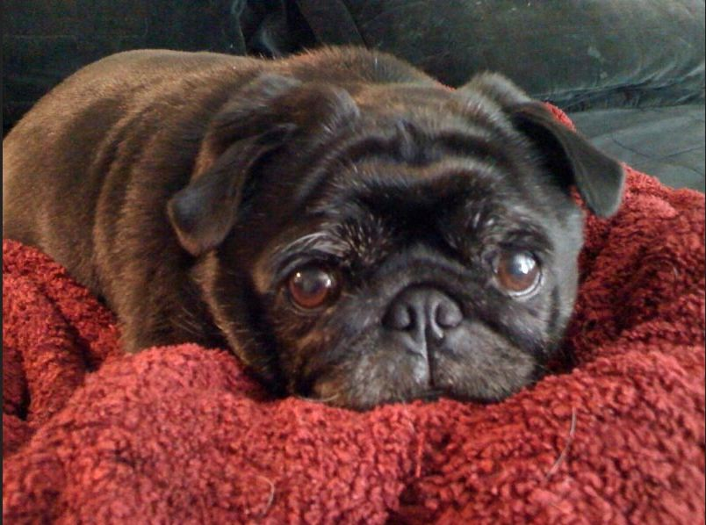

**Remembering a friend named Ivy Jane**

By Patrick B. McGuigan, Editor The City Sentinel

Ivy Jane, a 14-year-old “pug,” died on September 17.

In the years I have been reporter, editor, publisher and now editor again, this wonderful creature’s photographs appeared — more then any other sentient being’s “mug” – often on the cover of The City Sentinel

She had an interesting tribal dance, each time I went to visit the home of [Darla Jane Shelden](https://www.facebook.com/notes/darla-shelden/ivy-jane-shelden-feb-6-2002-sept-17-2015/10156123623700436), my friend and – for several years now – our lead reporter.

When I walked in, Ivy would grab a hedgehog doll in her mouth and “run” around me several times in a circle. Now and then she would look up, seeming to ask, “Why aren’t you giving me any loving?”

I would soon oblige, getting down on the floor to cuddle her and pretend I was trying to that doll away. As time passed, I learned this was her elderly version of those days when she would scurry on those tiny legs around visitors, a toy clenched in chubby cheeks.

Ivy gave me more than she got. That’s how the best furry persons are.

She was devoted and faithful to my friend. Ivy’s circle of love extended far and wide. She was always a star at the [Puggerfest](https://www.facebook.com/Puggerfest), appearing in a different costume each year. Those photographs made me smile so broadly that I directed we print at least one on the front page, with more inside. Ivy was a fan of President Obama, and often wore special gear to make that clear. She loved me, despite our political differences.

Little Ivy had been ailing since August with a runny nose.

Darla took her to the Vet, who did some tests.

Awaiting results from the last of those, we all hoped it would be something benign, but nature’s ways are not our ways.

Ivy died at 4:30 a.m. at home, near Darla, who earlier had fed her one last banana popsicle. Along with Darla and Ivy in the parlor was another human friend, Ivan Hutchcroft, who had come to help watch the little lady, whom he loved dearly.

Darla texted me the news. As I re-read the note during a quiet moment in class, one of my students, working on an assignment, asked what was wrong when she saw the look on my face.

I told her, “A friend died early this morning.”

Ivy Jane was a beautiful lady, not a pet. Her hair was black with raven tips and some gray around the sides. As I got to know her, it was hard to think of her as a dog, but rather as a furry person.

She had a wonderful life. I am blessed to have known her.

Read Darla’s [tribute to Ivy](https://www.facebook.com/notes/darla-shelden/ivy-jane-shelden-feb-6-2002-sept-17-2015/10156123623700436).