Celebrating our 45th Anniversary

January 13, 2016
The Creative Arts Center in Chatham, Massachusetts is excited to announce it’s 45th Annual Festival of the Arts, August 19th - 21st, 2016. This anniversary will showcase and celebrate120 Juried Fine Artisans and Craftsmen presenting hand crafted items, original artwork, jewelry, fabric, pottery, fashion, wood, glass and more.
The Festival has been called a “rite of summer” by the Cape Cod Chronicle and is the Premier Summer Arts Event in Chatham, known for pristine beaches, cool ocean breezes, and warm summer climate leading many to believe there is no better place to be than in Chatham. Held every year at Chase Park, just a short walk from downtown Chatham, the Festival is family friendly and features; not only beautiful artistic one of a kind pieces but a children’s arts and crafts tent, shuttle bus service and food trucks to support the large numbers of guests. The Festival is supported by a strong marketing budget that builds upon our long history of successful events to reach our target audience. The Creative Arts Center will provide an extensive print and radio marketing campaign, as well as a Banner lined Main Street to support the festival and bring the crowds.
As always, to ensure The Festival of the Arts continues with the high level of quality it has become known for, all exhibitors will be judged for acceptance. Enclosed please find an application with additional details. Submissions for consideration must be postmarked by April 1st. The Creative Arts Center has worked with hundreds of artists, like yourself, and is cognizant of the challenges inherent in exhibiting. As a recent exhibitor and working artist I want to extend my support for your efforts. Please contact me with any questions or for assistance. Our goal is to make this the most successful event you attend.
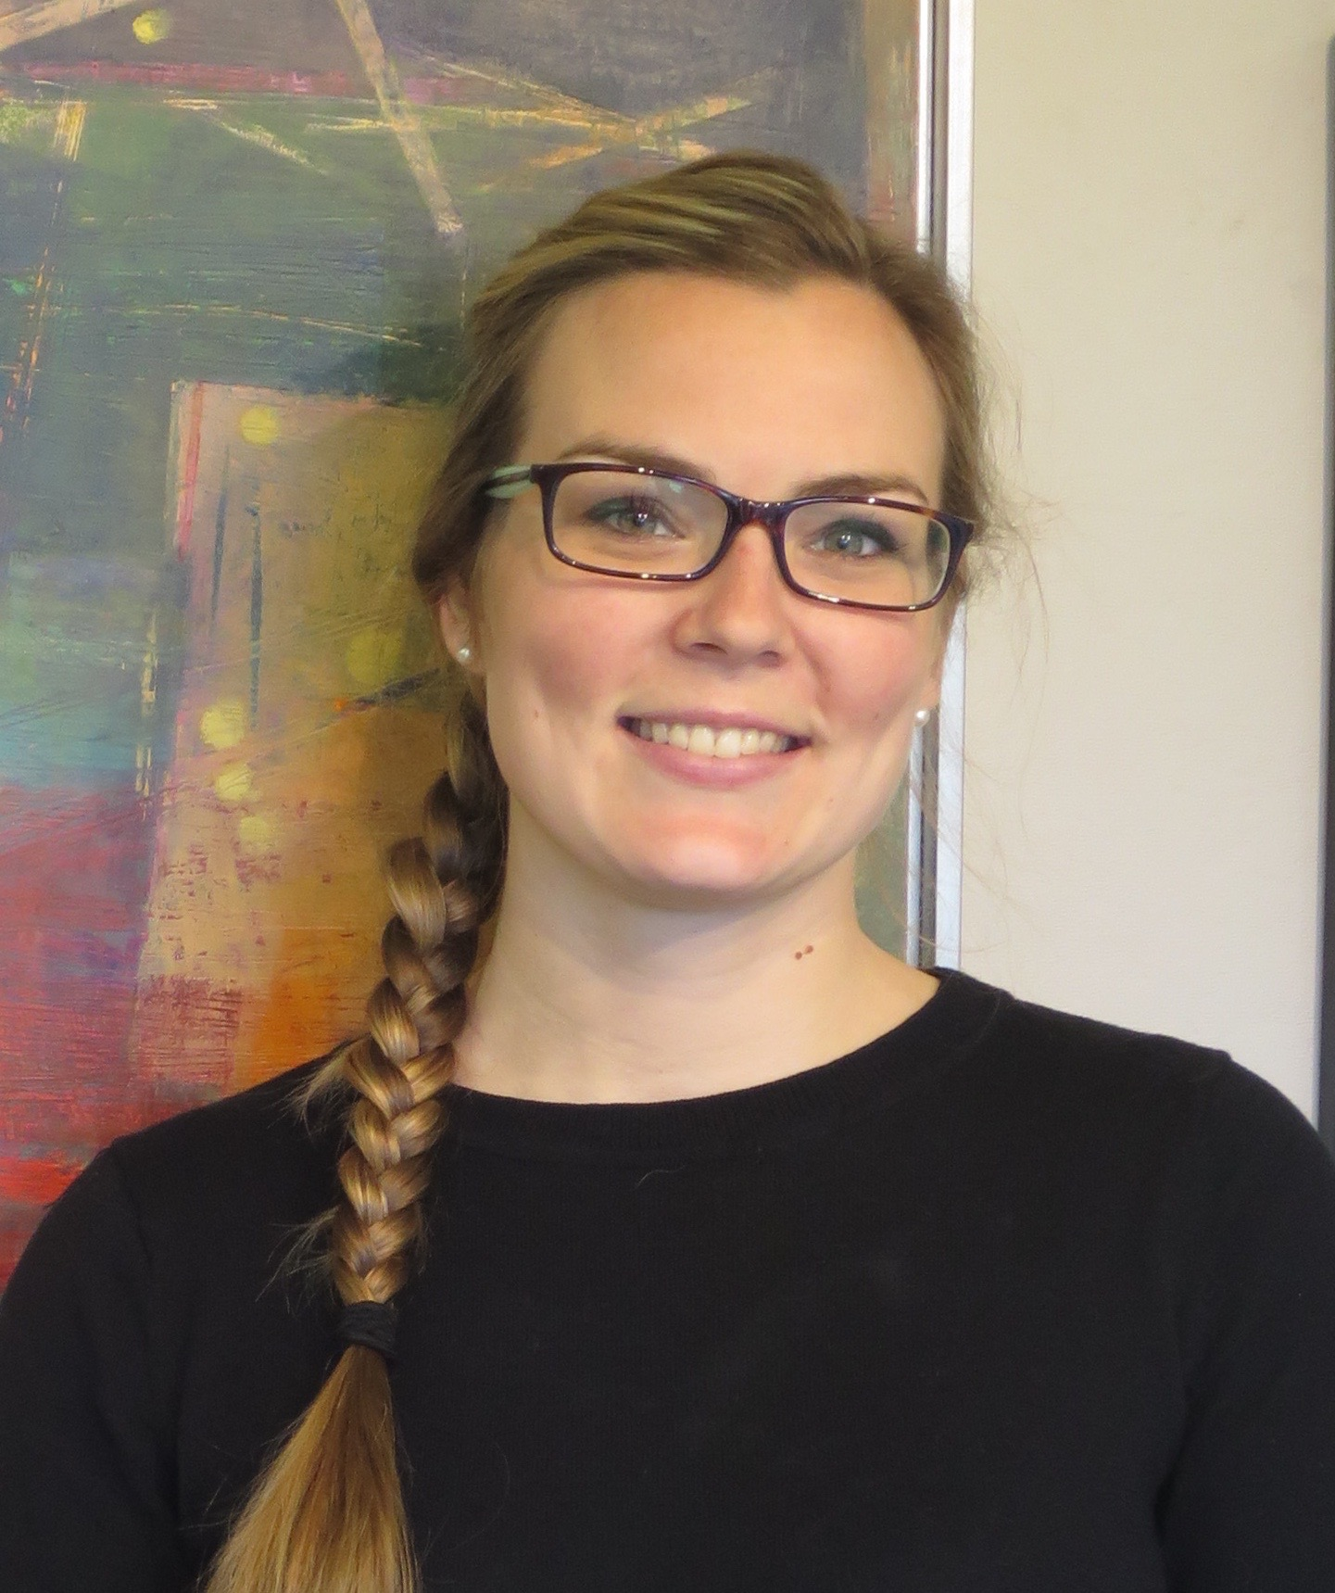

Sincerely,

Chelsie Starace
Festival Coordinator
Phone: 774 212 0427
Read what some of our Exhibitors have to say!
Best Studios has been fortunate to be accepted into this fabulous show for over 20 years. As far as we are concerned, it has the highest quality of handmade items in any Fine Arts and Crafts Show on Cape Cod. It continues to be a great show with great support and great people!
John and Elizabeth Best/ Best Studios
The Festival is well organized with a friendly and supportive staff. The venue and amenities are clean and well maintained. There is a high percentage of return customers, and a steady flow of new clients each year. The Festival attracts a huge crowd of discerning customers, that appreciate the quality and range of work for sale. This is a great Summer show, always a pleasure to exhibit at.
Rich Benson/Cape Cod Whale Carving

