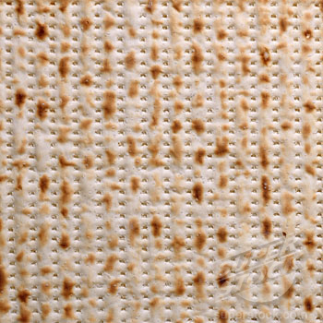
PASSOVER SERVICES SCHEDULE 5775
April 3-11, 2015

PASSOVER YOM TOV FIRST DAYS
APRIL 3rd, 4TH AND 5TH
Erev Pesach, Friday, April 3rd,
7 a.m. Shacharit, followed by siyyum and breakfast
5 p.m. Minha, Chapel
Shabbat Morning April 4th and Sunday, April 5th
9 a.m. Sanctuary

HOL HAMOED, INTERMEDIATE DAYS
MONDAY, APRIL 5TH-THURSDAY, APRIL 9TH
7 a.m. Morning Minyan, Shacharit, Chapel
6 p.m. Evening Minyan, Minha/Maariv, Chapel

PASSOVER, YOM TOV CONCLUDING DAYS
APRIL 9th, 10th and 11th
Thursday evening, April 9th , 6 p.m. Minha/Maariv Chapel
Friday Morning, April 10th
9 a.m., Sanctuary
Friday Evening, April 10th, 6 p.m. Chapel

Shabbat, 8TH DAY OF PASSOVER, April 11th
8:30 a.m. PLEASE NOTE CHANGE OF TIME. Services, Sanctuary, Including Yizkor service and chanting of Shiri Hashirim
9 p.m. Maariv/Havdalah to conclude Shabbat and Pesach, Chapel

