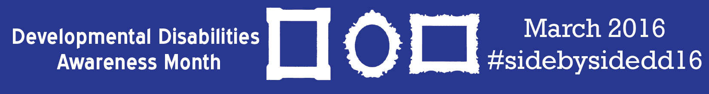

 | 1- Awareness Graphic * | 2- Blog: Definition of a more inclusive community | 3- Toolkit: Community Living | 4- Graphic: Side by Side Pictures *
7- Blog: Early Childhood Inclusion | 8- Resource: AXS Map | 9- Toolkit: Diversity and Inclusion | 10- Blog: Antonio’s Story | 11- Video: Voting
14- Graphic: Mississippi Highlight * | 15- Video: Tuesday’s with Liz | 16- Resource: Transition to Community Life | 17- Resource: Building Natural Supports | 18- Toolkit: Guide to Educating Policy Makers
21- Video: Getting Real in Georgia | 22- Blog: Why the DD Act Matters | 23- Video: Inclusive Employment Success | 24- Toolkit: Community Employment | 25- Video: Mixed Greens
28- Video: Inclusive Childcare | 29- Graphic: Call for Stories * | 30- Video: The Next Step | 31- Resource: People First Language | Closing Post- Close the campaign with the post from page 3!

*Download graphics
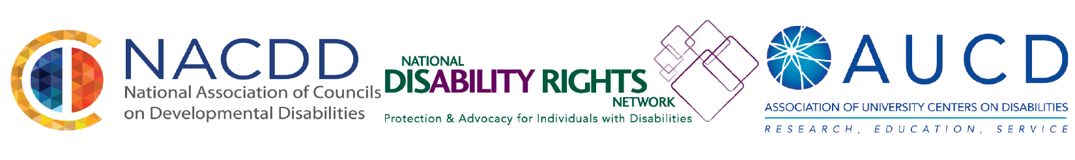

Copy and paste these statuses to your Facebook along with content from the calendar!
Use these statuses as a template for your tweets!
Be sure to tag organizations from chart provided on page 4!

March 1- Join us this March to spread awareness of people with developmental disabilities, side by side. Share your photos, stories and videos! #sidebysidedd16 (Tag: AUCD, NDRN, NACDD)

March 2 – Today, we are looking to Administration on Community Living to discover a more inclusive definition of diversity. #sidebysidedd16 (Tag: ACL)

March 3 – AAIDD and AUCD explored community living options and residential supports. Check out their findings! #sidebysidedd16 (Tag: AAIDD and AUCD)

March 4 - Have you shared your photos, stories and videos yet? Be sure to tag #sidebysidedd16

March 7 – Learn from Administration on Community Living on how early childhood inclusion benefits children with disabilities! #sidebysidedd16 (Tag: ACL)

March 8 - AXS Map identifies accessible places in the community using crowdsourcing. Add to the map and find more accessibility in your community! #sidebysidedd16 (Tag: AXS Map)

March 9 – This Diversity and Inclusion Toolkit from AUCD is perfect to develop strategies on how to promote more inclusion! #sidebysidedd16 (Tag: AUCD)

March 10 – Read how inclusion and opportunity impacted Antonio! #sidebysidedd16 (Tag: Southern Mississippi)

March 11 – Oregon Council on Developmental Disabilities wants you to vote. And so do we! #sidebysidedd16 (Tag: Oregon Council on Developmental Disabilities)

March 14 – The Mississippi Council on Developmental Disabilities was honored with The Eternity Award from the Brain Injury Association of Mississippi. #sidebysidedd16 (Tag: Mississippi Council on Developmental Disabilities)

March 15 – A chat on employment, and working side by side. A special Tuesday with Liz: featuring Sara Luterman. #policy4all #sidebysidedd16 (Tag: AUCD, Tuesday with Liz)

March 16 – Read stories of transitioning to independence from Ohio Developmental Disabilities Council. #sidebysidedd16 (Tag: Ohio Developmental Disabilities Council)

March 17 – Natural Supports are an important part of inclusion. Read about natural support from The Arc of the United States #sidebysidedd16 (Tag: The Arc of the US)

March 18 – Educate your policy makers about why inclusion and supports matter to you! Check out this toolkit from AUCD #sidebysidedd16 (Tag: AUCD)

March 21 – See how ‘real communities’ are making a difference in Georgia #sidebysidedd16 (Tag: Georgia Council on Developmental Disabilities)

March 22 – Want to know why the DD Act matters? Administration for Community Living spells it out. #sidebysidedd16 (Tag: ACL)

March 23 – Check out Don’s employment story from Oregon! #sidebysidedd16 (TAG: Oregon Council on Developmental Disabilities)

March 24 – Working side by side for inclusive employment! #sidebysidedd16 (Tag: Montana Council on Developmental Disabilities)

March 25 – In Savannah, Georgia at the Farmer’s Market, you’ll find people working side by side to eat healthy and create a stronger community. Check out this video produced by Georgia Council on Developmental Disabilities. #sidebysidedd16 (Tag: Georgia Council on Developmental Disabilities)

March 28 – “It’s really not as difficult as people imagine.” Watch how Shaun and Brendan learn side by side in inclusive childcare; a video from the Maryland Developmental Disabilities Council. #sidebysidedd16 (Tag: Maryland Developmental Disabilities Council)

March 29 – It’s not too late to share your photos, stories and videos of how you stand side by side with people with disabilities! Be sure to tag #sidebysidedd16

March 30 – Is higher education the next step for you? Texas Council for Developmental Disabilities highlights standing side by side and education opportunities for people with disabilities. #sidebysidedd16 (Tag: Texas Council on Developmental Disabilities)

March 31 – Spread awareness about people with disabilities living, working and playing side by side. Read up on person centered language from Texas Council for Developmental Disabilities. #sidebysidedd16 (Tag: Texas Council for Developmental Disabilities)

March 31 – Living, working, learning, and playing side by side with people with disabilities all year long makes us ALL better. Follow @AUCDnetwork @NACDD, & @NDRNadvocate all year long for more tips, tools, and stories as we work together to create a more inclusive community.

Use the Twitter Handles and Facebook Profiles below to tag organizations for the Social Media Calendar

Twitter Handles
• @AUCDNews
• @_aaidd
• @ACLgov
• @georgiacouncil
• @axsmap
• @DisVisibility
• @emily_ladau
• @AXSChat
• @OCDD
• @Disabilitygov
• @Tuesdaywithliz
• @MgmAUCD
• @AndyAUCD
• @PHis4Everyone
• @RootedInRights
• @TheArcUS
• @NatCounDis
• @NDRNadvocates
• @NJDC07
• @southernmiss

Facebook Profiles
• @Association of University Centers on Disabilities (or @AUCDnetwork)

• @AAIDD
• @Administration for Community Living
• @Georgia Council on Developmental Disabilities
• @AXS Map
• @Words I Wheel By
• @AXSChat
• @Oregon Council on Developmental Disabilities
• @Texas Council for Developmental Disabilities
• @Mississippi Council on Developmental Disabilities
• @Disability.gov
• @Michael Gamel-Mccormick
• @Andy Imparato
• @Rooted in Rights
• @The Arc of the United States
• @Maryland Developmental Disabilities Council
• @The University of Southern Mississippi
• @Montana Council on Developmental Disabilities

