Jason Dow
Director
3 Years
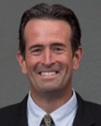
Jason Dow was appointed general manager of the Central Marin Sanitation Agency (CMSA) in 2002. He began his career with CMSA in June 1993 as a University of California, Berkeley, College of Engineering intern and was then hired permanently as an engineering technician in December of 1993. Jason graduated from University of California, Berkeley in with his Bachelor of Science in civil engineering and received his Masters of Science in environmental engineering from San Francisco State. He is a California registered civil engineer.

Scott Goldman
Director
3 Years
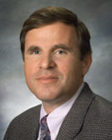
Scott Goldman has been on the Board of Directors of the El Toro Water District since 2000 and is
currently vice president. He was appointed to the Board of the South Orange County Wastewater Authority in 2006 as the representative for El Toro, and served as chairman from 2010 to 2014.
Scott is also a senior vice president at RMC Water and Environmental located in the Irvine office. He has 35 years of experience in the planning, design and construction of various aspects of water, wastewater and recycled water systems.
Scott holds a Bachelor of Science in water resource engineering from University of California, Los Angeles and a Masters of Science in environmental engineering from University of Southern California. He is a registered civil engineer in California, Arizona and Nevada, and an environmental engineer certified by the American Academy of Environmental Engineers.

Grace Robinson-Hyde
Director
3 Years
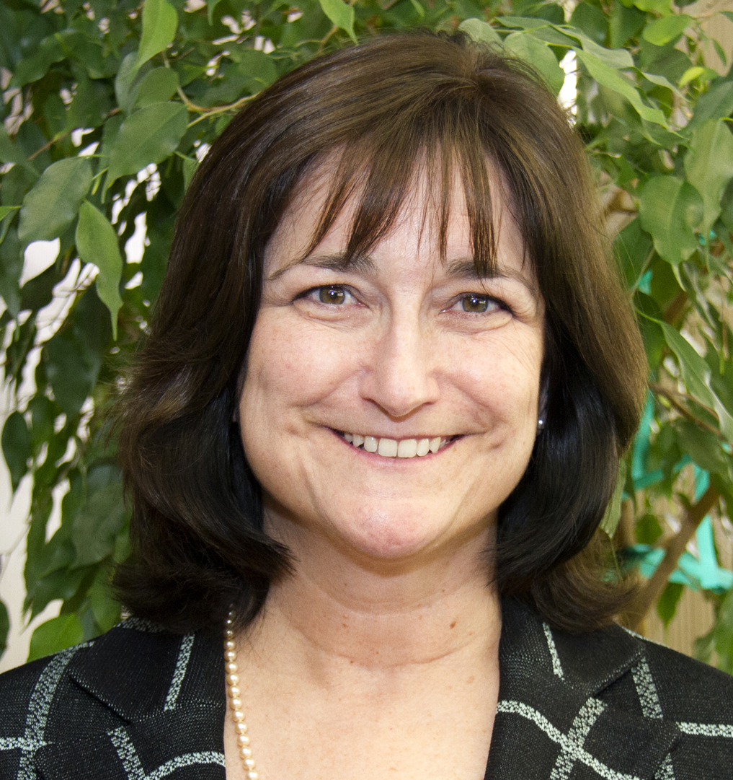
Grace Robinson Hyde, with 33 years of agency experience, currently serves as the Chief Engineer and General Manager of the Los Angeles County Sanitation Districts. In this role, she manages all operations of the Sanitation Districts, which provide wastewater and solid waste management services for over 5.5 million people. She oversees approximately 1,700 employees and an annual budget of over $700 million. Since September 2013, she has served on the CASA Program Planning Committee as Vice Chair and, most recently, Chair. Grace also serves on the following boards and commissions: Commerce Refuse-to-Energy Authority Board, Inland Empire Regional Composting Authority Board, Puente Hills Habitat Preservation Authority Board, Santa Monica Bay Restoration Commission, and Southern California Coastal Water Research Project Commission. She received a B.S degree in Civil Engineering from the University of Texas at Austin and an M.S degree in Environmental Engineering from the University of North Carolina at Chapel Hill. Grace is a registered Professional Civil Engineer in California and is a Board Certified Environmental Engineer by the American Academy of Environmental Engineers.

Traci Minamide
Director
3 Years
Traci is the chief operating officer for the City of Los Angeles, LA Sanitation. In this capacity, she assists the director by maintaining bureau-wide oversight of operational activities in a program that consists of three core services: wastewater collection and treatment, solids resources, and watershed protection (stormwater). Her main area of focus is in wastewater treatment, water recycling, and biosolids management where over 450 million gallons per day are collected and treated. Traci has been with the city for 25 years and has previously served with the city’s Department of Water and Power and the Irvine Ranch Water District. She has served in many capacities including water planning, industrial pretreatment, environmental regulations, and wastewater treatment.
Traci holds a Bachelor of Science in civil engineering from California State Polytechnic University at Pomona and a Master of Science in environmental engineering from Loyola Marymount University. She is also a licensed professional civil engineer in the State of California and a board certified environmental engineer.

