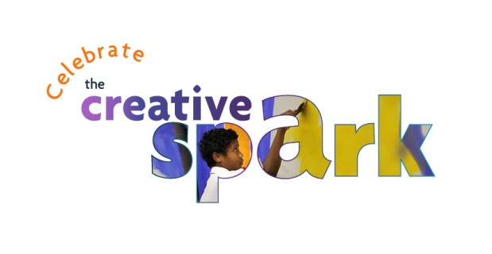
School Participant Interest Form

DC Commission on the Arts and Humanities (DCCAH) seeks District-based arts organizations experienced in offering programming for children and youth to deliver arts workshops as part of a month-long celebration of the arts during National Arts in Education Month in March 2016.

Celebrate the Creative Spark! is designed to meet DCCAH’s goal of developing the creative capacity of children and youth in the city. Participating arts organizations will have the opportunity to build new relationships with schools and share the process and value of their work with them. Workshops will take place in DC Public and Public Charter Schools across all eight wards of the city, and will reflect the process-driven activities done in arts classrooms that build the creative skills of students.

School:
Name and Title of Primary Contact:
Best Contact Email:

Best Contact Phone Number:

Workshop Discipline Interest: (Circle/highlight all that apply)

Theatre Dance Music Visual Arts Media

If you participated in the initiative in March 2015, might you be interested in working with the same workshop presenters? If so, please list below:

Targeted Age(s)/Grade(s):

Number of residencies willing to accommodate:
(A single residency consists of a unit of three lessons)

Preferred Dates/Range of Dates in March:
(e.g. early/mid/late)

Time: (Circle/highlight all that apply)

In-school After-school

******************************************************************
Please note the following considerations before submitting this form:

Teachers and Schools are expected to work with designated Arts Organization / Teaching Artist(s) and the DC Commission on the Arts and Humanities (DCCAH) to:

- Identify mutually agreeable dates and times for workshops;

- Secure an appropriate space for workshops;

- Implement a short (5-minute) post-residency assessment provided by DCCAH; and

- Coordinate the documentation of the residency through photo/video if requested by DCCAH.

Schools interested in participating should complete this form and return it to David Markey at david.markey@dc.gov by Friday, December 18, 2015. Questions should be directed to david.markey@dc.gov / 202-671-1354.

