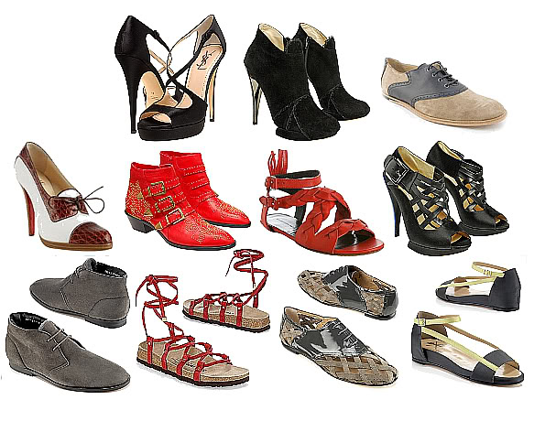
It’s Spring Cleaning Time…
2nd Annual
SHOE COLLECTION FUNDRAISER
Suicide Prevention and Mental Health Resources

Support a great cause while taking some clutter off your hands! We are collecting reusable shoes (in pairs) to be redistributed where they are greatly needed. Our goal is to collect 5,000 pairs of shoes. Empty your closets, garage and storage spaces of unwanted shoes. Ask your family, friends, neighbors, church, small groups and coworkers for their shoes too!

HESPERIA  Only Drop When Open Please  C Street Station Vintage & Antiques  9460 C Avenue  Tues - Sat 10 - 5, Sun closed  Carriage House Antiques  11370 Hesperia Road  Mon - Sat 10 - 5, Sun. 11-5  Christian Treasures  Bible Bookstore    12052 Hesperia Road  Mon - Fri 9:30 - 6:00  Sat. 10 - 5, Sun closed  ORANGE COUNTY  Call Kathryn Ross (949) 716-7235 | APPLE VALLEY  Drop in Front of Garage Door  - 13177 Setancket Rd.  - 13375 Rincon Rd.  VICTORVILLE  13390 Dean Ave  Drop in Front of Garage Door  Victorville Glass Co  15295 Seventh St.  Mon - Fri 8-5  Leave in box in Lobby  Moses House Thrift Store  14464 Atstar Dr. Ste. 201  Mon - Fri 9-5  Only Drop When Open  RIVERSIDE/SAN BERNARDINO  @ 215 & Barton Rd.  22196 Emerald St., Grand Terrace  Drop in front of garage door


Shoe Collection Deadline is May 15

Questions? Call Sue (760) 985-3295 or email lilgaryslegacy@cox.net

lil' Gary's Legacy is a Ministry of Christian Resource Center
P.O. Box 80852, Rancho Santa Margarita, CA 92688
Visit http://lilgaryslegacy.org for more information about
Suicide Prevention and Mental Health Resources

Christian Resource Center a 501(c)(3) non-profit organization

