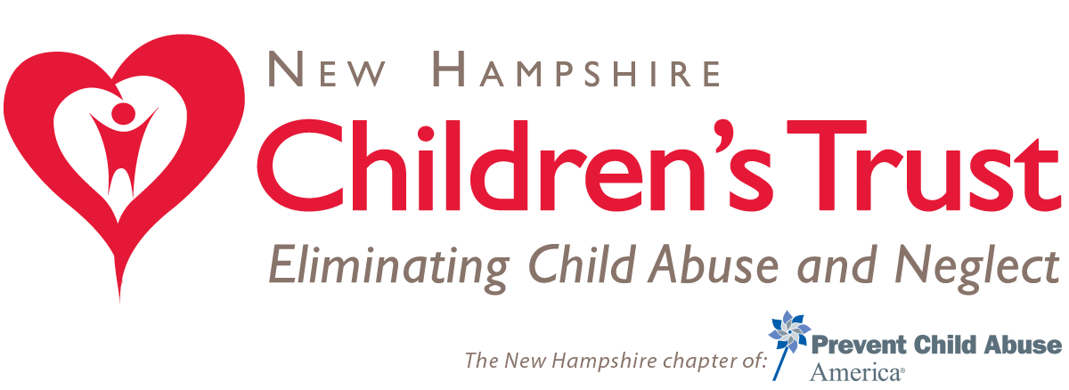

Sample email message to House and Senate members:

Prevent Child Abuse America and NH Children’s Trust are committed to strengthening the federal response to the protection of children and the prevention of child abuse and neglect, we urge your support for funding essential programs serving vulnerable children and their families in the FY 2016 Labor-HHS-Education Appropriations bill. Investing in healthy child development through evidence-based prevention and protection strategies is consistent with goals of ensuring our nation’s future prosperity. In particular, we request that within the Child Abuse Prevention and Treatment Act (CAPTA) you increase funding for the state grants to $29.5 million, the Community-Based Prevention grants (CB-CAP) at $42 million, and maintain research grants at $29 million. We also urge you to restore funding to $281 million for the preventive and protective services funded by the Title IV-B, Child Welfare Services (CWS). Thank you in advance for your support and commitment to these vital programs.

