3rd Annual
OUTDOOR CLASSROOM
OPEN HOUSE!

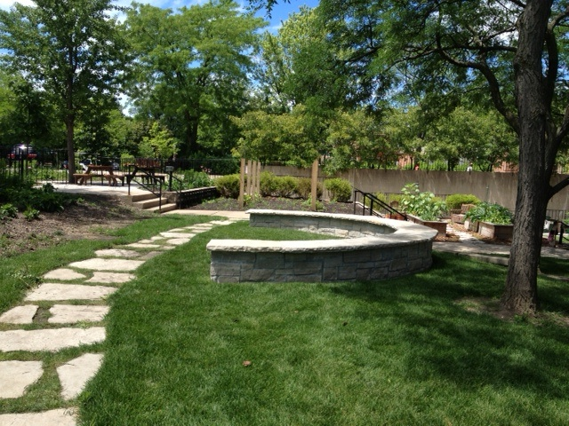

THURSDAY, SEPTEMBER 24^{th*}
3:15pm-5:00pm
Drop by anytime!

Proudly featuring food from our harvest made by our
practical arts classes
Refreshments, Tours, Garden Activities, and Games

^{PLUS}
Meet expert gardeners from The Organic Gardener, and purchase From the Ground Up, by owner and local resident, Jeanne Nolan.

*Rain date: Friday, SEPTEMBER 25th
Sponsored by the JSSPVA

