Den Chief Training
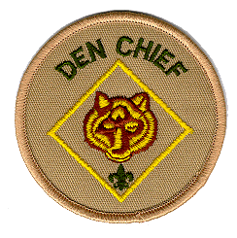 | Saturday, October 17, 2015  9:00 am – 12:00 pm  Magnolia United Methodist Church  1764 Wilroy Road  Suffolk, VA 23434  Cost: $5.00
The Den Chief is a critical member of the Cub Scout leadership team. To be successful, he must realize how important his job really is. Den Chief Training is intended to build enthusiasm for the job, develop high morale, and teach the skills he will need to be successful.
Presented in a single half-day session, this training combines fun and enjoyment with an excellent character building experience. Participants will learn leadership, organization and, most importantly, how to work with Cub Scouts.
This training is also for adult leaders (packs and troops) who want to learn the duties of a Den Chief.
REMEMBER: DEN CHIEFS CAN BE A TROOP’S BEST RECRUITING TOOL!!!
Cut Off Date: Monday October 12, 2015
Questions?
Contact: Billy Gardner (757) 539-0139 (gardnerrecovery@yahoo.com)

Registration fee includes: Den Chief’s Handout and a trained patch
Please register me for Den Chief Training on October 17th.
Name |  |  |  |  |  | Unit #
BSA Number:
OR
Address
Phone |  |  |  | E-Mail
I am a (select one)  Youth Member/Rank |  |  |  |  | Adult Leader/Position

