Questionnaire for 2015 Sister Library Participants

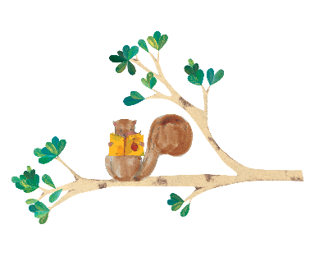
Library name :
_____________________________________________________________
Library Address:
__________________________________________________________
Library Website:
__________________________________________________________
Library blog/social media tags:
____________________________________________________________________________

Thank you for your interest in the Sister Library partnership. Last year we had some very positive experiences but we also received some constructive feedback. To that end we would like to gather additional information on your unique library situation in order to better pair you with another like-minded library. Please respond to the questions below. This will help with the pairing process, and will allow us to match libraries with similar goals and resources for the program.
- What is the primary interest in being a Sister Library?
Please indicate the most relevant answer from the options below, using 1 for most relevant and 3 for least relevant.
For the library staff to be able exchange ideas/experiences with another library in Canada.
As a way for children in your library to interact with children at a library in another part of Canada.
For both a staff exchange of ideas and a way for the children to interact with children in other parts of Canada.

- Are you answering on behalf of a system with many locations or a single location (your branch)?
On behalf of a system with many locations (answer question 3)
Single location (skip to question 4)

- If you are answering on behalf of a system, approximately how many locations will be involved in the sister library partnership?

- What is the approximate population of the community your library serves? (If you belong to a larger system of libraries, please respond based on the population served by your branch only.)

Under 1,000
1,000-5,000
5,000 – 15,000
15,000 – 50,000
Over 50,000

- On average how many children participate in your TDSRC programs?

- What methods of communication would you use during interactions with your Sister Library (check all that apply)?

Mail (Canada Post)
Email
Phone calls
Shared social media (eg.Facebook, Pinterest, Instagram)
Video conference (eg.Skype, Google Chat)
Other

- How frequently would you be available to communicate with your Sister Library during the summer?

More than once a week
Once a week
Less than once a week

- I will be away from ________________________To _______________________________________

- Would there be someone available to replace you during your vacation or should you become sick?
Yes
No

- What sort of activities would you be interested in doing? (eg. Video chats, souvenir/photo exchanges, penpals, joint activities, library challenges)

____________________________________________________________________________________________________________________________________________________________________________________________________________________________________________________________________________________________________________________________________________________

- Would you be willing to partner with a library in the same province as yours, but in a different city, town, or region?
Yes
No

- Please choose the language you wish to participate in:
English
French
Bilingual

If you participated last year and wish to be paired with the same library again, (if possible) please indicate the name of your Sister Library from 2014. ____________________________________________________________________________________

- My contact and Library information:

Name of Sister Library coordinator: ____________________________________________________
Email address of Sister Library coordinator: ______________________________________________
Telephone numbers of Sister Library Coordinator: _________________________________________

THANK YOU!

