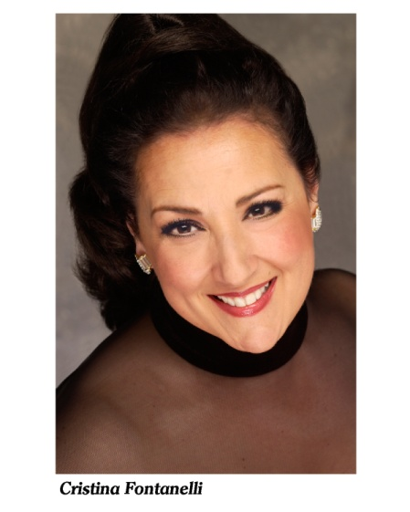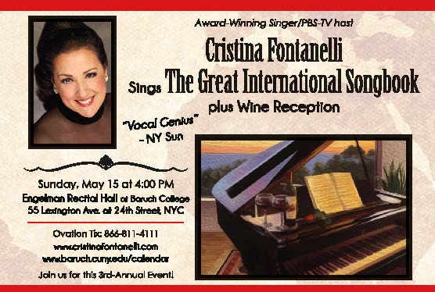

Award-winning Singer Cristina Fontanelli Promotes World Peace Through Song
Award-winning Singer/PBS-TV host, Cristina Fontanelli (www.cristinafontanelli.com) sings "The Great International Songbook, plus wine reception" Sunday, May 15, 2016 at 4:00 at the Engelman Recital Hall at the Baruch College Performing Arts Center in New York City. The 3rd-annual concert highlights songs of many countries to promote world peace through the universal language of music. This year’s concert is in collaboration with the Monday, May 16 World Trade Conference at Baruch College (http://www.worldtradeweeknyc.org/) as May has been designated “World Trade Month” by the international business community. http://trade.gov/worldtrademonth/

New York, NY – 03/10/2016 -- Award-winning singer and PBS/WNET and NY affiliates host for “Andrea Bocelli: Live From Central Park" and "Il Volo Takes Flight" CRISTINA FONTANELLI brings her third-annual concert program of the world's best-loved classic songs during her "The Great International Songbook, plus wine reception" at Engelman Recital Hall at the Baruch Performing Arts Center at Baruch College on Sunday, May 15 at 4:00. Ms. Fontanelli will perform songs and arias in 8 languages accompanied by world-class musicians on piano (Robert Wilson) and such instruments as flamenco/samba guitar (John La Barbera), balailaika, accordion (Lenny Feldman) and mandolin. Child ballroom dancers, Simona Tamburello (7 years old) and Jonah Mussolino (8 years old) will perform the rhumba/cha cha. Guest tenor, gospel choir and celebrity emcee t/b/a.
Called a "Vocal genius" by the New York Sun, Ms. Fontanelli envisioned this international musical program to preserve the great folk and classic songs/arias of the world and to bring ethnic communities together in an annual musical celebration to promote peace and understanding through the universal language of music. Songs will include such Spanish classics as "Granada", French classics such as "La Vie en Rose", classic Italian songs such as “Torna a Sorriento” and “O Sole Mio”, German, Japanese, Korean, Yiddish and other languages, plus popular opera arias/duets.
Listen to Ms. Fontanelli performing the song “Hymn a l’amour” at Feinsteins at the Regency Hotel in New York https://www.youtube.com/watch?v=fP1HegoASbc . She has sung title roles with the Palm Beach, New Jersey and Cairo Opera companies, with The Boston Pops, the St. Louis Symphony, at Feinstein’s at the Loews Regency Hotel and has performed for Jimmy Kimmel’s “Feast of San Gennaro” in Hollywood. She is the voice of “Nonna” on PBS Chef Lidia Bastianich’s animated Christmas special; and is the “voice” of Domino’s Pizza on the national radio commercial. Ms. Fontanelli has performed for the Clinton White House, the President George W. Bush’s Inaugural Ball in 2005, and has completed 3 world tours with the Mantovani Orchestra. In November of 2014 Cristina Fontanelli was invited by the Italian Government (Puglia Region) as a world-wide artist of Pugliese descent to sing in Bari and Molfetta, Italy.
About Cristina Fontanelli
Brooklyn-born Cristina Fontanelli was awarded the OSIA Lifetime Achievement Award in the Arts (previous recipients include Luciano Pavarotti), has been cited as one of the top alumni of the American Academy of Dramatic Arts (along with Robert Redford, Anne Bancroft, Cecil B. Demille, Anne Hathaway et al) and has been named “Woman of the Year” by many Italian organizations throughout the country.
Engelman Recital at the Baruch Performing Arts Center is located at 55 Lexington Avenue at 24th Street, New York, NY and tickets for "The Great International Songbook, plus Wine Reception" are sold through OvationTix at 866-811-4111 and online at https://web.ovationtix.com/trs/pe.c/9986160 . Tickets cost $62.50 (Premium admission), $54.50 (general admission) and $47.50 (Seniors – ID checked at door). Ticket price includes the wine/dessert reception. Student discounts are available. Ms. Fontanelli’s website is http://www.cristinafontanelli.com. Directions to the Baruch Performing Arts Center are: by Subway*#6 to 23 St. (north exits to 24th & Park Av. So.);
N, R to 23 St. (at Broadway); F, M, PATH to 23 St. (at 6th Ave.); IRT #1 to 23 St. (at 7th Ave.);
C, E to 23 St. (at 8th Ave.) and by Bus* M23 crosstown bus via 23rd St.; buses via Lexington or 3rd Av. or Madison Av1/2/3, J/Z, A/C to Chambers Street Station.

