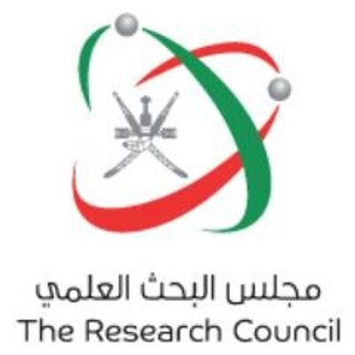
OMAN’S RENEWABLE ENERGY STRATEGIC RESEARCH PROGRAM
The Research Council (TRC) in Oman has been mandated by the Government of the Sultanate of Oman to initiate a Renewable energy strategic research program. This research program is one of the strategic research programs funded by TRC. The research program focus on four themes:

- The use of renewable energy for cooling and air-conditioning
- The use of renewable energy for water desalination systems
- Energy efficiency
- Power generation and storage.

TRC is aiming to achieve the following objectives under this program:

- Identify the most important areas of scientific research for Oman which can contribute to experimental renewable energy research and provide scientific solutions.

- Support and conduct experimental pilot research projects in the identified areas using the latest scientific solutions, information and techniques.

- Provide realistic scientific facts to decision makers on evidence-based solutions, which will help in planning of formulating regulations and policies.

- Enhance capacity building in the field of renewable energies, program development and creating a motivational research environment.

- Increase the mutual cooperation and networking between academic and industrial organizations, and maximize the benefit from cooperation with various international organizations.

- Develop a platform to host links to databases to provide all of the required weather data, raw data, geographical data, reports and the latest research outcomes.

- Disseminate the outcomes of the program to stakeholders through awareness activities.

Within the next two months TRC is planning to issue an invitation to receive research proposals for potential Research / Technology Pilot Projects. TRC will select the most promising proposal for realization either funded by the Omani Government or including a finance proposal over 5 years including Operation and Maintenance.

The program is open for local Omani and International Companies. Each participant must enter into a cooperation with an Omani University as their local Research Partner. International Companies are further required to have a local Omani Cooperation Partner to qualify.

We advise all research institute/ companies who are interested in the program to regularly check the TRC website (https://www.trc.gov.om) for further announcements.
We are looking forward to receiving interesting proposals for innovative renewable energy Pilot Projects.

Dr. Ahmed Said Al Busaidi
Program Manager – Renewable Energy Research
The Research Council

