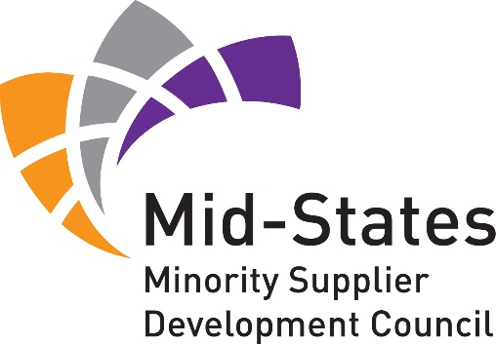
2015 Business Opportunity Fair
Registration List as of 3/20/15
*Please note that this list is not complete and booth assignments are not yet available. When complete we will publish the booth assignment list for your information and use. It will also be available at registration counter during the event.
CORPORATIONS
Allison Transmission | Honda
Anthem | Citizens Energy Group
Faegre Baker Daniels | Cummins Inc.
Cricket Wireless | Eli Lilly & Company
Delphi Electronics & Safety | Duke Energy
Toyota Motor Engineering & Manufacturing | Vectren Corporation
Messer Construction Co. | Purdue University
Morgan Stanley | John Deere
Ivy Tech Community College | Indianapolis Power & Light
Indiana State University | University of Southern Indiana
ConAgra Foods

MBEs
Fineline Printing Group | Hanzo Logistics
Harris & Ford, LLC | Mays Chemical
Performix | Quest Safety Products
Telamon Corporation | Thorpe Energy Services
Engaging Solutions | Alliance Group Technologies Co.
DTM Real Estate Services, LLC | Group O
Meadows Office Supply | Main Event Merchandise Group
SmartIT | Powers & Sons Construction
Indiana Bridge, Inc. | Geyer Fire Protection, LLC
Professional Environmental Engineering | Success Promotions
World Wide Technology

