It is with great pleasure that the Valley Artisans’ Co-op would like to announce that Susan Fraser SCA was recently elected into The Society of Canadian Artists. This honor was conferred on her at the prestigious Arts and Letters Club of Toronto. The Society of Canadian Artists is a national, non-profit artists’ organization dedicated to expanding the visibility and stature of the visual arts. The SCA recognizes the highest qualities in art through a program of awards. It organizes and administers public exhibitions of the work of members and non-members, adhering to a standard of artistic excellence. Fostering a community for artists through exhibitions, workshops, lectures and communications is a major tenet of the society. The SCA provides leadership within the arts community in Canada through the encouragement of original, artistic expression and experimentation in all media and all visual art forms. There are 281 Elected professional artists members across Canada and 99 Associate members.
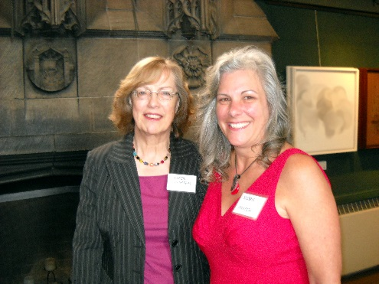

Photo: Karin Richter SCA, Exhibition Director for the Society of Canadian Artists with Susan Fraser SCA (right)

The venue of The Arts and Letters Club of Toronto began in 1908 when Augustus Bridle, a journalist covering Arts and Culture, gathered the leading writers, musicians, architects, academics and supporters of the arts to found an organization to champion the arts. The Arts and Letters Club quickly became a forcing-ground for ideas for shaping Canada’s artistic culture. The Group of Seven painters, Vincent Massey, Governor General of Canada, Robertson Davies, novelist, Sir Edmund Walker, banker and generous patron of the arts, Marshall McLuhan, philosopher, Sir Ernest MacMillan, conductor and composer and many more laudatory members supported and challenged each other to create a national cultural identity.
Guest speaker for the event was Katarina Atanassova, Curator of Canadian Art at the National Gallery of Canada speaking on Exhibiting Canadian Art.
Susan, as an Elected member, has gone through the adjudication process. The jurying process takes months to complete as five jurors across Canada assess the candidates’ work. She was also granted Drawing Master status from The Drawing Society of Canada and holds a Bachelor of Biological Sciences, which is the foundation of her detailed drawings of the natural world.

“That is one of the nice things that I really like about the Coop - our artists are still being widely recognized for their excellence and quality work!”
Mary Lynn Benz, President of Valley Artisans’ Co-op.

