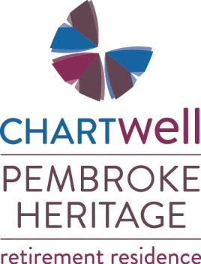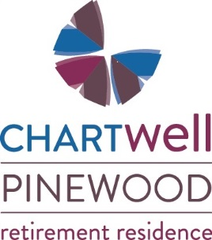

Short Stay Program Available Over the Summer Months
Suitable for Respite, Convalescence, Trial Stay or a “Staycation”
$59 / Day Includes:
~ Fully Furnished Suite
~ Telephone and Cable TV
~ 3 Meals Daily + Snacks
~ Medication Administration (if needed)
~ Weekly Housekeeping

Please contact Leigh Costello for more information at 613-775-5009 or lcostello@chartwell.com

