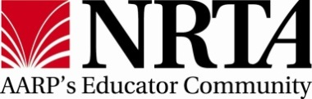
Setting: Tool for Engaging Younger Members

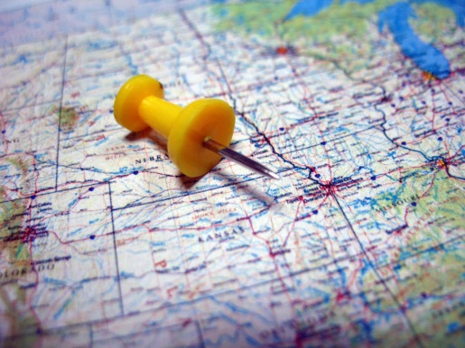
You can use a variety of techniques to create an experience setting that the 50 to 64 demographic find innovative and appealing.

Use location to define the audience's feeling. Along with selecting the time, determining location often is one of the first planning tasks. When making this important decision, consider:
- Meeting people where they are. This means choosing a location in a neighborhood close to or near where people live and work, or one that is central to a cluster of people. As a rule of thumb, most people won't travel more than 30 minutes to attend an event.
- Piggybacking on a popular spot. Take advantage of existing popular locations to make your experience more accessible. This could mean planning experiences around local festivals, sporting events, farmer's markets or other community happenings.
- Making it easy to get there. Choose venues with easy and (ideally) free parking. Make sure that your space is accessible and has good lighting and signage that clearly marks the event entrances. You don't want a newcomer lost because they couldn't find the right door.
- Look for local flair. Find spaces that are unique and special to a community. Choose a place people know and love, or find a hidden gem that speaks to what the community is. This familiarity will help people associate your REA with a location they love.
The space should be designed for the experience. Once the location is selected, design the space for your experience to influence how people interact with each other, and you will shape their impression of your REA. For example, utilize "zones" that you want people to experience:
- Orientation Zone - Where attendees are welcomed and signed-in for an event. Attendees might receive a warm greeting, a nametag, or an information packet about the meeting.
- Exploration Zone - Where attendees learn. This could be a display board about the work of your REA. Or, it could pose a question to consider that opens the attendee's mind.
- Conversation Zone - Where people connect with others. A natural conversation zone is the refreshment table. To encourage conversation and mingling, add a few high tables for food and beverages while they chat.
- Participation Zone - Where people learn and are expected to pay attention. It's the space where the formal part of a meeting or workshop is held.
We hope these tools inspire you to invest time in carefully examining setting for the experiences you are planning. You will strengthen your event by incorporating these techniques around location and zones into your event.

Check-out our “Checklists for Setting (1 and 2”) when you start to plan your next event!

