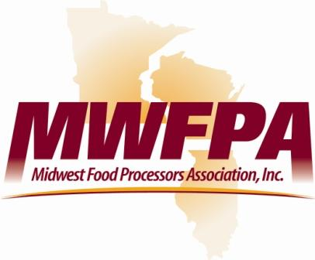

TO: MEMBERS, JOINT COMMITTEE ON FINANCE
FROM: NICK GEORGE, PRESIDENT – MIDWEST FOOD PROCESSORS ASSOCIATION
DATE: OCTOBER 28, 2015
RE: TRANSPORTATION FUNDING

The Midwest Food Processors Association respectfully urges that you approve Wisconsin DOT’s request for $200 million in general obligation bonds for this fiscal year and for the remaining $150 million in contingency bonding provided for in the state budget.
Our association represents food processors that own and operate over 100 facilities throughout Illinois, Wisconsin and Minnesota. Our members contract with over 7,000 independent growers in the three-state area and have an estimated economic impact of over six billion dollars. In addition we represent over 250 companies that serve the food processing industry. The ability of Wisconsin’s roads and bridges to be both safe and have capacity is important to MWFPA members.
Approving the $200 million contingent bonding for the current fiscal year will provide $125 million to fund the Major Highway Development Program, which would advance vital projects across the state. The remaining bonding would provide $75 million to fund the State Highway Rehabilitation Program, which would restore 220 miles of projects that were removed from the 6-year program in the state budget.
MWFPA shares the concerns you may have about borrowing funds for roads without first having in place a long-term financing solution. However, MWFPA believes strongly that state investment in our highways is necessary for boosting economic productivity, competing in the global economy, and maintaining a better quality of life. We support moving Wisconsin to a funding system that provides certainty for the state’s future transportation needs. We look forward to working with you to achieve that goal in the next budget.
Thank you for your consideration of these views.

