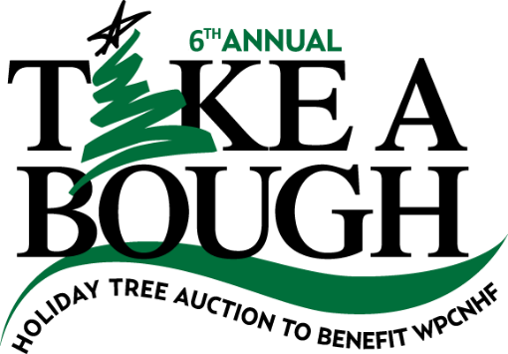
2015
SPONSORSHIP OPPORTUNITIES
LEVELS & BENEFITS

Presenting Sponsor $15,000
· Exclusive naming rights, “Presented by:___________________”
· 20 invitations to the donor recognition event
· Company recognition provided at the donor recognition event
· Banner display at event (company supplied)
· Name and/or Logo on all print marketing and advertising materials as “Presenting Sponsor”.
· Logo display on all web promotions including website, Facebook, social media and e-blasts
· Opportunities to distribute promotional items at event (company supplied and distributed)

Gold Sponsor $10,000
· 15 invitations to the donor recognition event
· Company recognition provided at the donor recognition event
· Banner display at event (company supplied)
· Name and/or Logo on all print marketing/advertising materials
· Logo display on all web promotions including website, Facebook, social media and e-blasts
· Opportunities to distribute promotional items at event (company supplied and distributed)

Silver Sponsor $5,000
· 10 invitations to the donor recognition event
· Company recognition provided at the donor recognition event
· Logo on event postcard, event posters and event signage
· Logo display on all web promotions including website, Facebook, social media and e-blasts
· Opportunities to distribute promotional items at event (company supplied and distributed)

Bronze Sponsor $2,000
· 5 invitations to the donor recognition event
· Company recognition provided at the donor recognition event
· Name recognition on event postcard and posters, Logo on event signage
· Logo display on all web promotions including website, Facebook, social media and e-blasts
· Opportunities to distribute promotional items at event (company supplied and distributed)

Supporting Sponsor $1,000
· 3 invitations to the donor recognition event
· Logo display on all web promotions including website, Facebook, social media and e-blasts
· Opportunities to distribute promotional items at event (company supplied and distributed)

Patron Sponsor $500
· 2 invitations to the donor recognition event · Logo display on Take A Bough website

